

Project Execution part-2

Content Migration



|  |  |
| --- | --- |
| Assignment Name | Content Migration Part -2 |
| Name & Student # | Abirami Mohanasundaram (8886811)  Mounika Boju (8921717)  Parth Babubhai Kalathiya (8884149)  Rechael Vincent Lopes (8928886) |
| Program | INFO8826 – Capstone II |
| Course & Section | 4 |
| Professor Name | Hitarth Smart |
| Due Date | November 17th , 2024 |

Declaration

We, Abirami Mohanasundaram, Mounika Boju, Parth Babubhai Kalathiya, and Rechael Vincent Lopes affirm that the attached work is entirely my own, except where the words or ideas of other writers are specifically acknowledged in accordance with accepted APA citation conventions. This assignment has not been submitted for any other course at Conestoga College or any other global institution. I acknowledge that I have revised, edited, and proofread this paper, and I certify that I am the author of this paper. Any assistance I received in its preparation is fully and properly acknowledged and disclosed. I have also cited any sources from which I used data, ideas, theories, or words, whether quoted directly or paraphrased. I further acknowledge that this paper has been prepared by myself specifically for this course.

Our team has spent approximately 10 hours on this assignment.

Signatures

Mounika Boju



Abirami Mohanasundaram



Rechael Vincent Lopes



Parth Babubhai Kalathiya



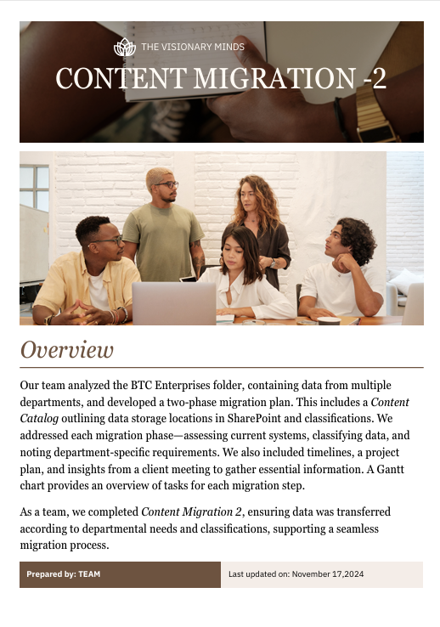

## Abstract

This document presents a comprehensive analysis of the BTC Enterprises folder, which contains data and files from various departments, along with a detailed migration plan structured in two phases: Migration 1 and Migration 2. It includes a Content catalog outlining data storage locations in SharePoint and their classifications. The migration approach covers critical aspects such as system assessment, data classification, and department-specific requirements. The document also highlights timelines, planning details, and key client meeting insights to ensure the migration aligns with organizational objectives. A Gantt chart visually represents task distribution and milestones throughout the migration process. With the completion of Content Migration 2, this document has been updated to reflect the finalized migration outcomes and serves as a guide for effective SharePoint data management moving forward.

Academic Abstract Word Count:130

Table of Contents

Abstract 3

Environment Setup 5

Site Configuration 9

Document Libraries 14

Document Library Security 18

First Migration 22

First Migration Documentation 25

Second Migration 27

Second Migration Documentation 29

Client Meeting Needs 29

Task Creation for Migration 30

Tasks creation post-meeting with Client 31

Gantt Chart 31

Team Contributions 31

References 32

Appendix 32

# Environment Setup

We have completed the environment setup and created active site.

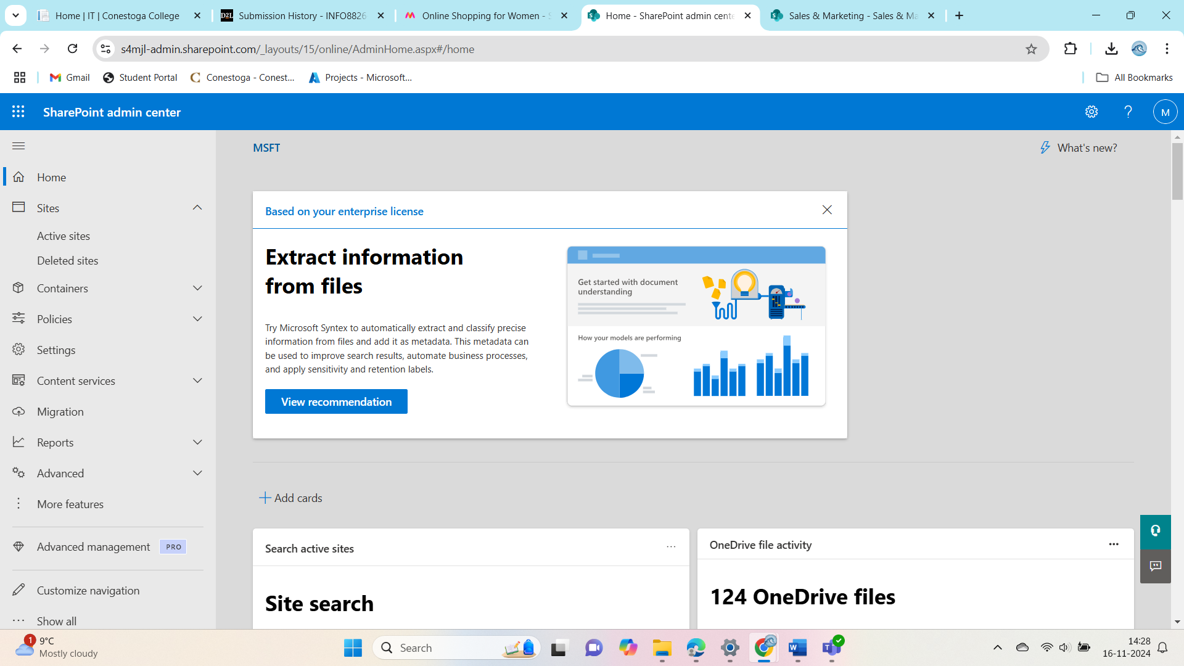

Figure 1 Shared point admin center

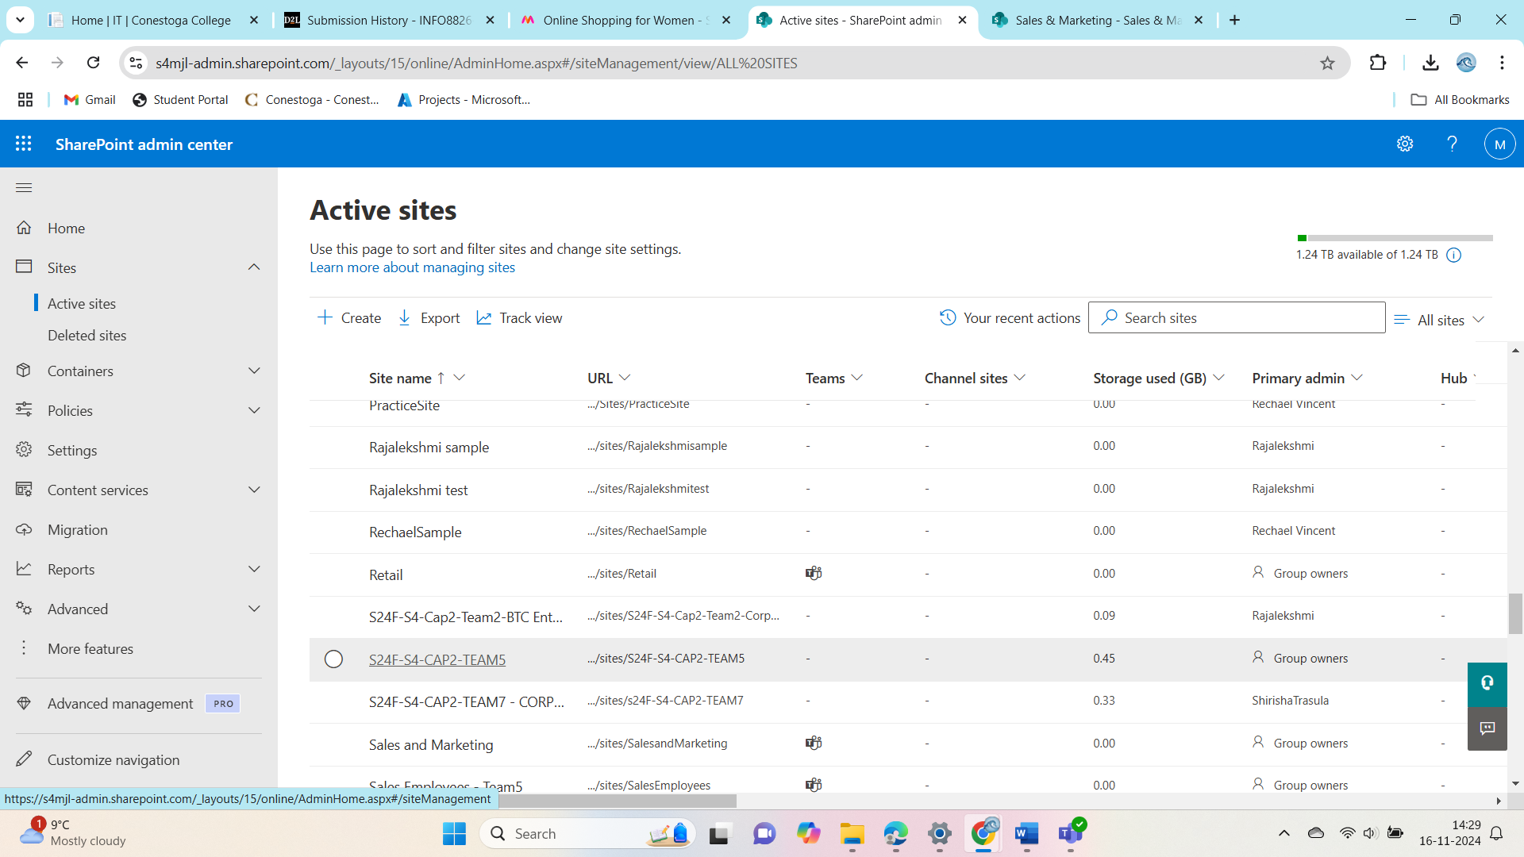

Figure 2 active site of our SharePoint

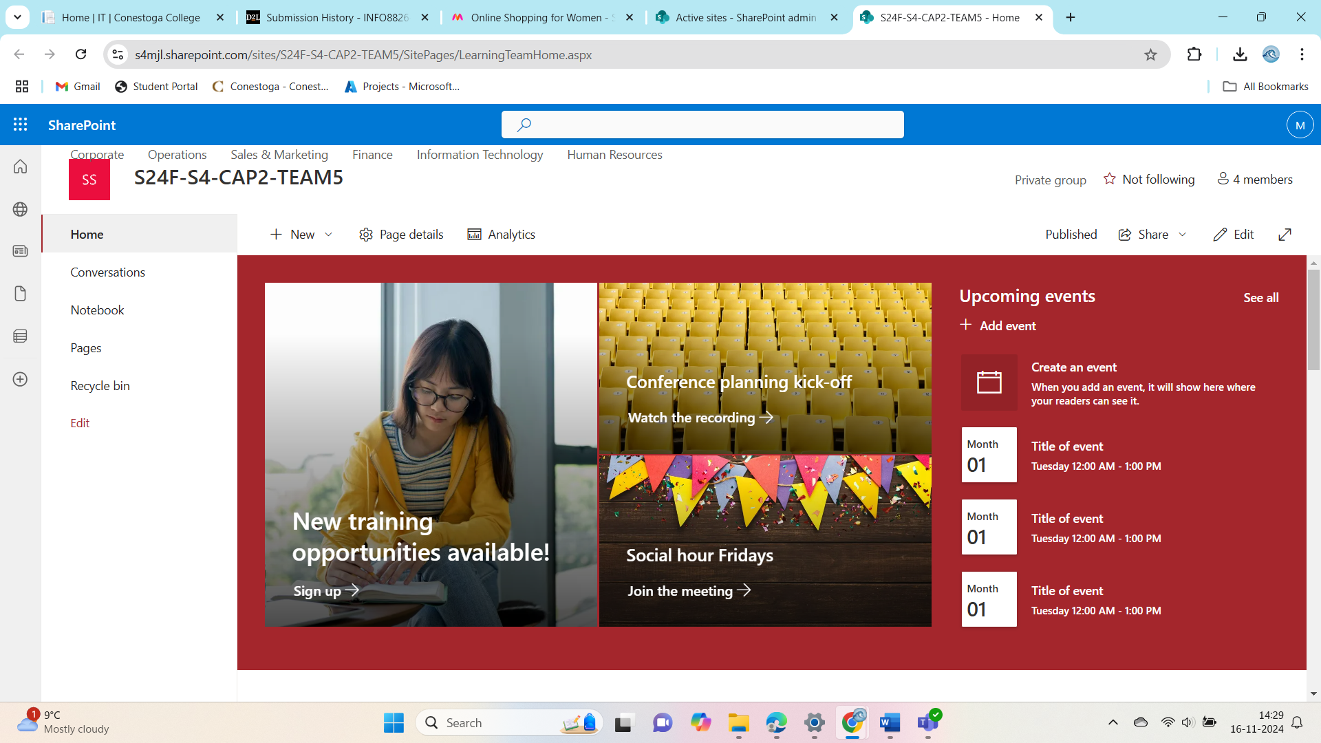

Figure 3 Main page of our SharePoint site

One item That was missed for the client is verifying and assigning content ownership and permissions. While the site is set up, configured, and users and groups are in place, we need to ensure that files and folders have the correct permissions and that sensitive data is properly secured.

**Here’s how we’ll address this:**

**Review Permissions:**

We’ll double-check that all files and folders have the right permissions in place. Sensitive data, like HR and Finance documents, will be restricted to the appropriate teams or individuals.

**Assign Ownership:**

We’ll assign clear ownership for specific libraries and files to the right stakeholders. This will help with accountability and ongoing content management.

**Get Client Feedback:**

Once permissions and ownership are updated, we’ll share them with the client for review. If they have any changes or feedback, we’ll make those adjustments.

**Provide Documentation:**

We’ll create a simple guide for the client that explains the permissions structure and how they can manage it in the future.

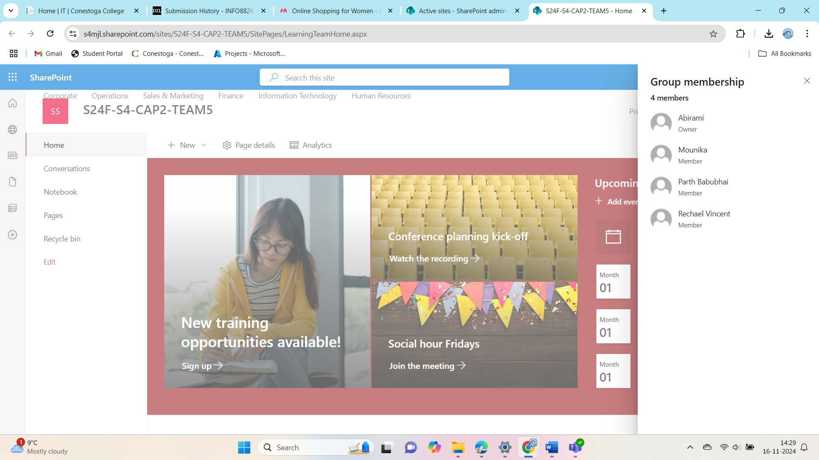

Figure 4 members added to group

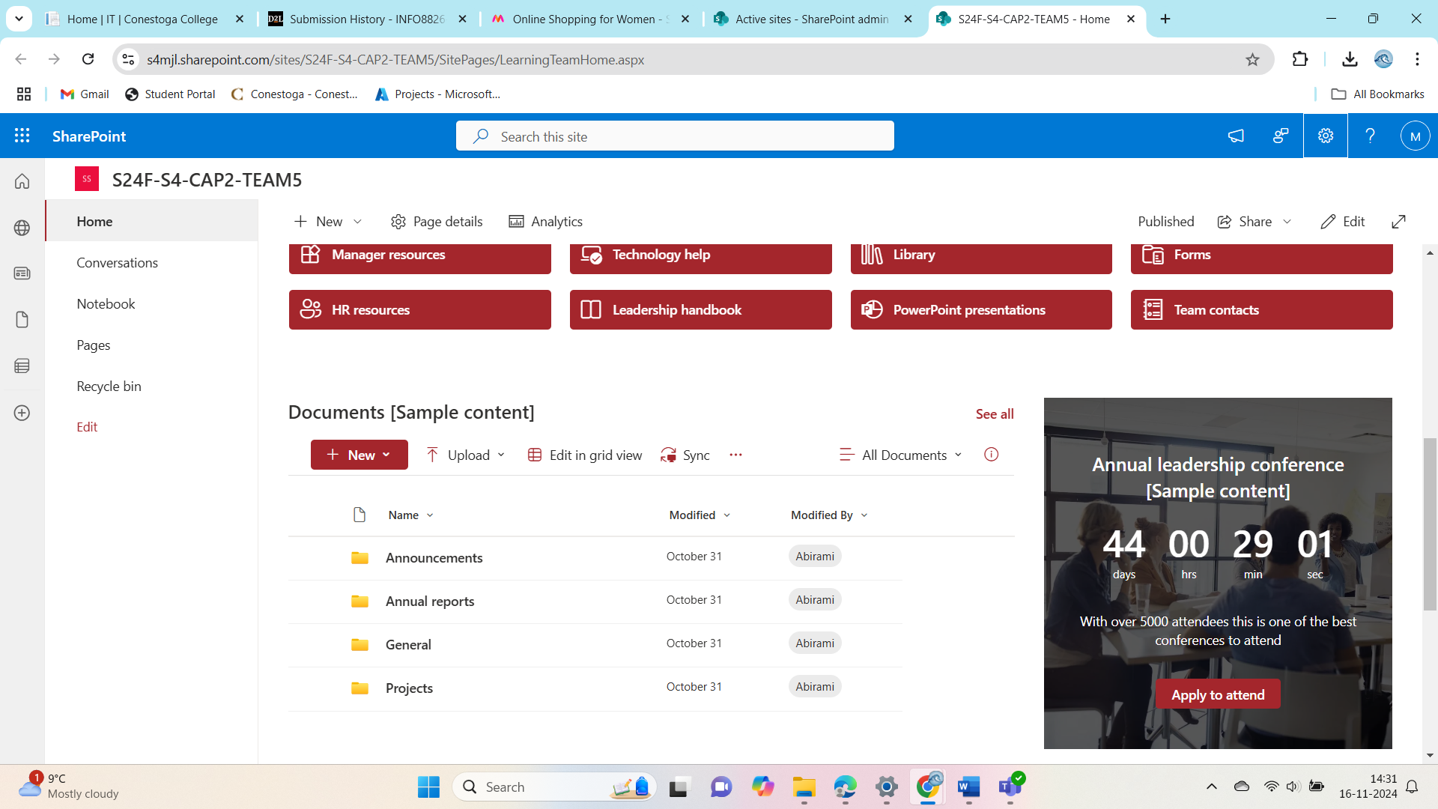

Figure 5 recent Documents uploaded

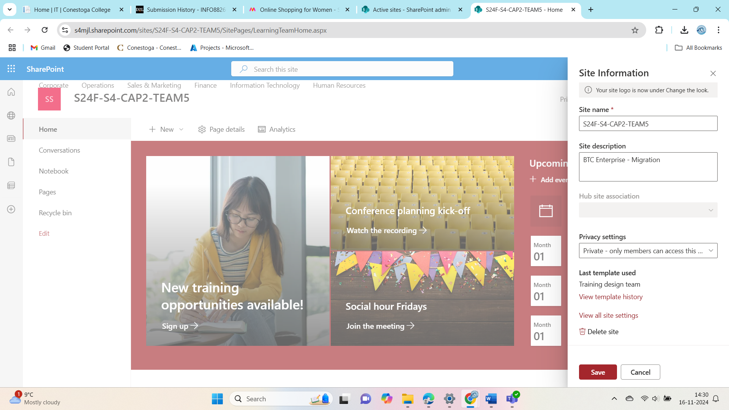

Figure 6 Our active site Information

# Site Configuration

The top-level site, along with sub-sites for all departments, has been successfully created and configured.

**Details of Site Configuration:**

**Top-Level Site:**

* The top-level site serves as the central hub, providing access to organizational-wide resources, announcements, and shared documents.
* It is configured with global navigation to ensure easy access to department-specific sub-sites.

**Sub-Sites for Departments:**

**Finance:** Configured with secure libraries for financial reports, statements, and budgets, with restricted access to authorized personnel.

**Human Resources:** Includes dedicated areas for employee records, recruitment documents, and policy updates.

**Marketing:** Equipped with libraries for campaign materials, creative assets, and presentation templates.

**Operations:** Designed to host operational guidelines, schedules, and team updates.

**Purchasing:** Contains folders for purchase orders, vendor contracts, and procurement workflows.

**Sales:** Focused on housing sales reports, client data, and performance dashboards.

**IT:** Configured with technical documentation, support resources, and project tracking tools.

**Configuration Highlights:**

* Permissions:

Each sub-site has department-specific permissions, ensuring access is limited to relevant teams.

* Customization:

Libraries and lists are customized to align with departmental workflows.

* Navigation:

Intuitive navigation links are provided between the top-level site and sub-sites for seamless user experience.

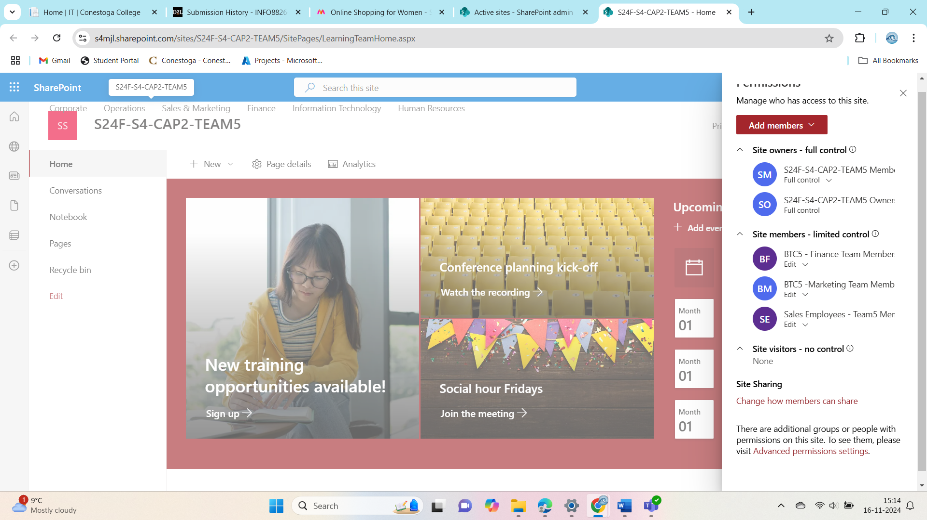

Figure 7 Main active site Configuration and access

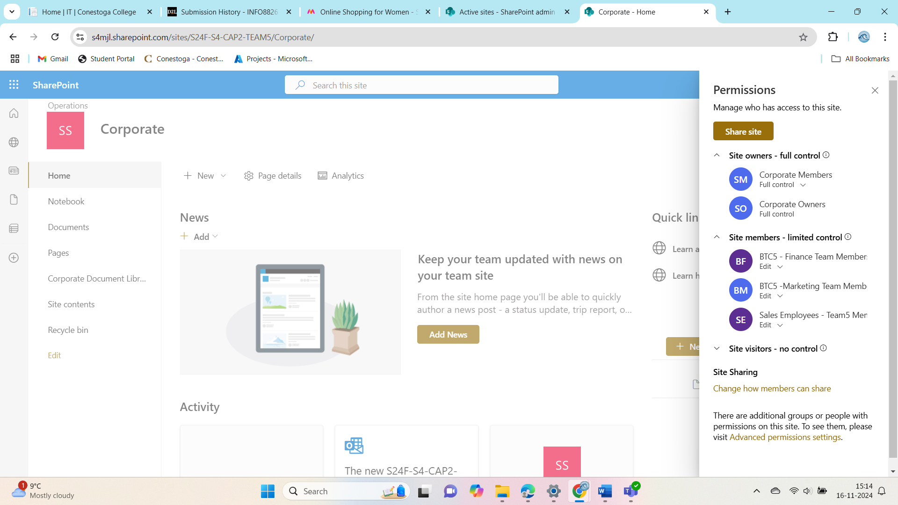

Figure 8 Corporate page site permissions

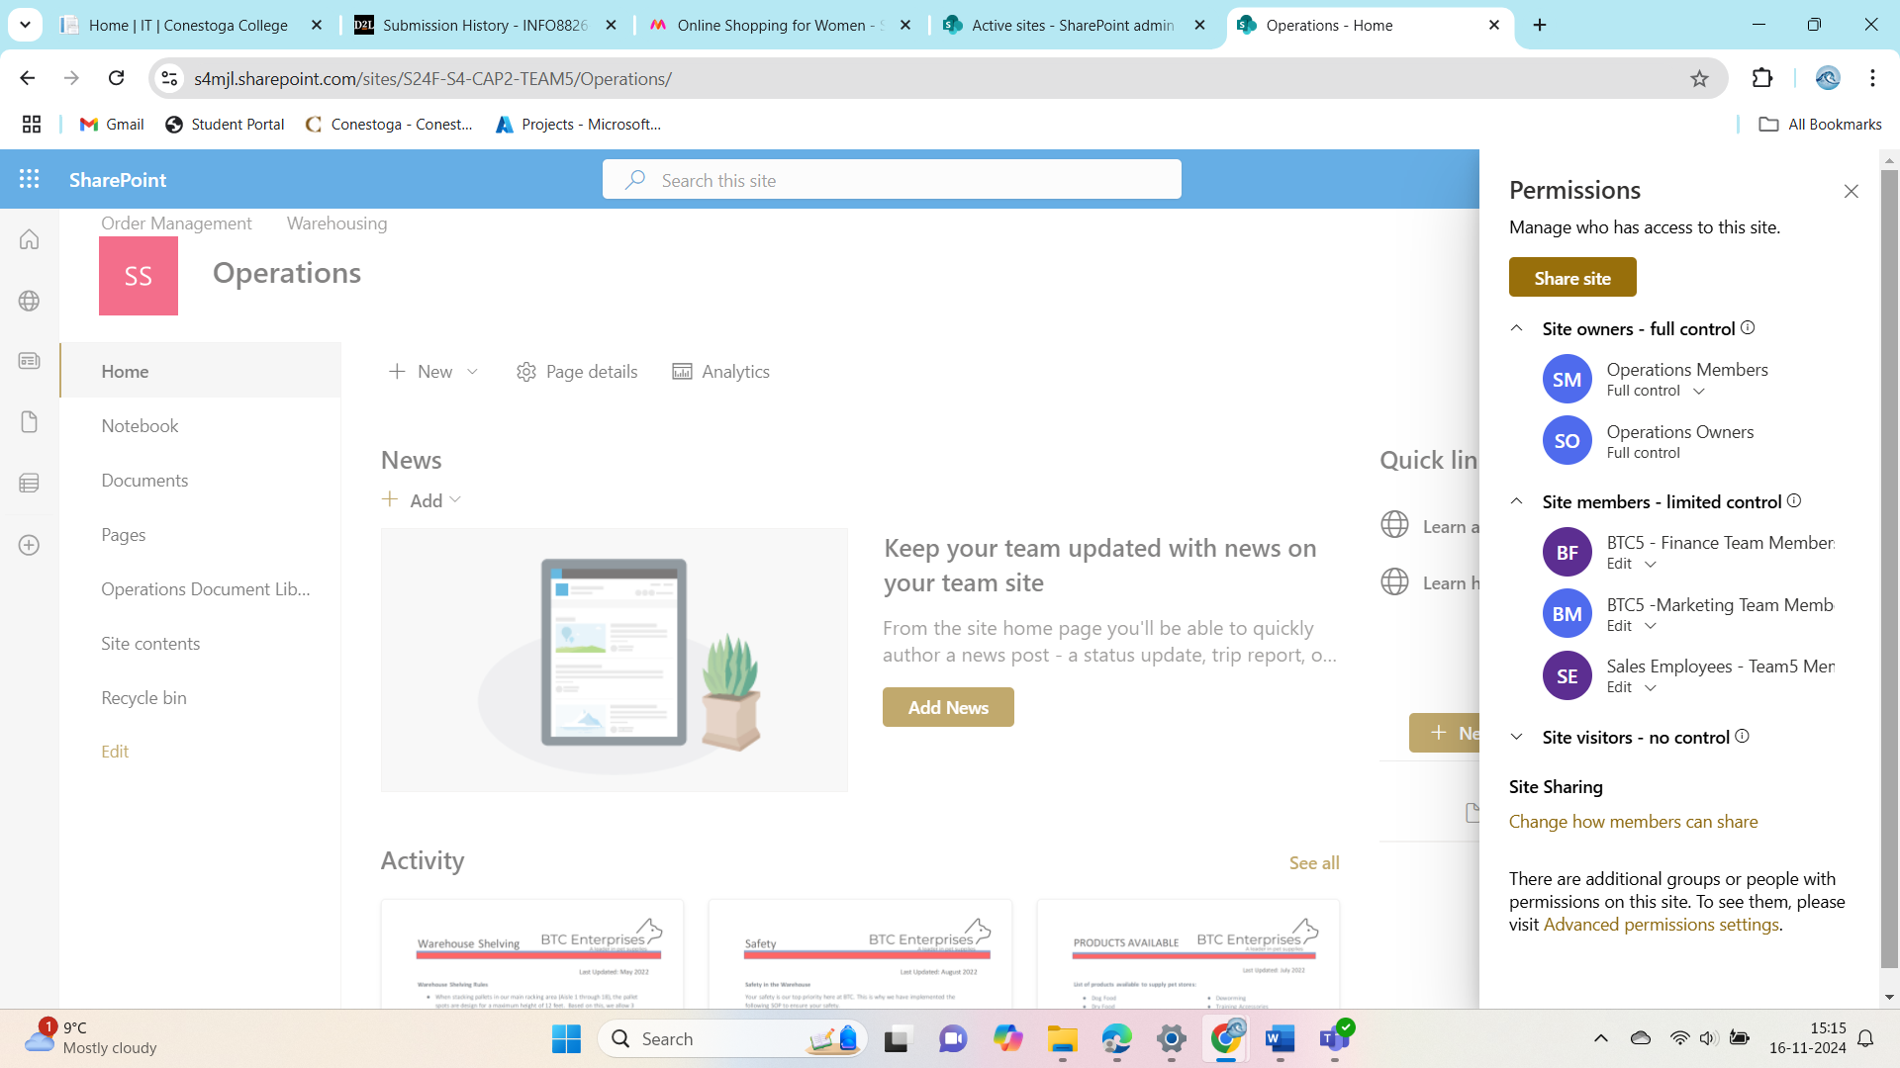

Figure 9 operations page site permissions

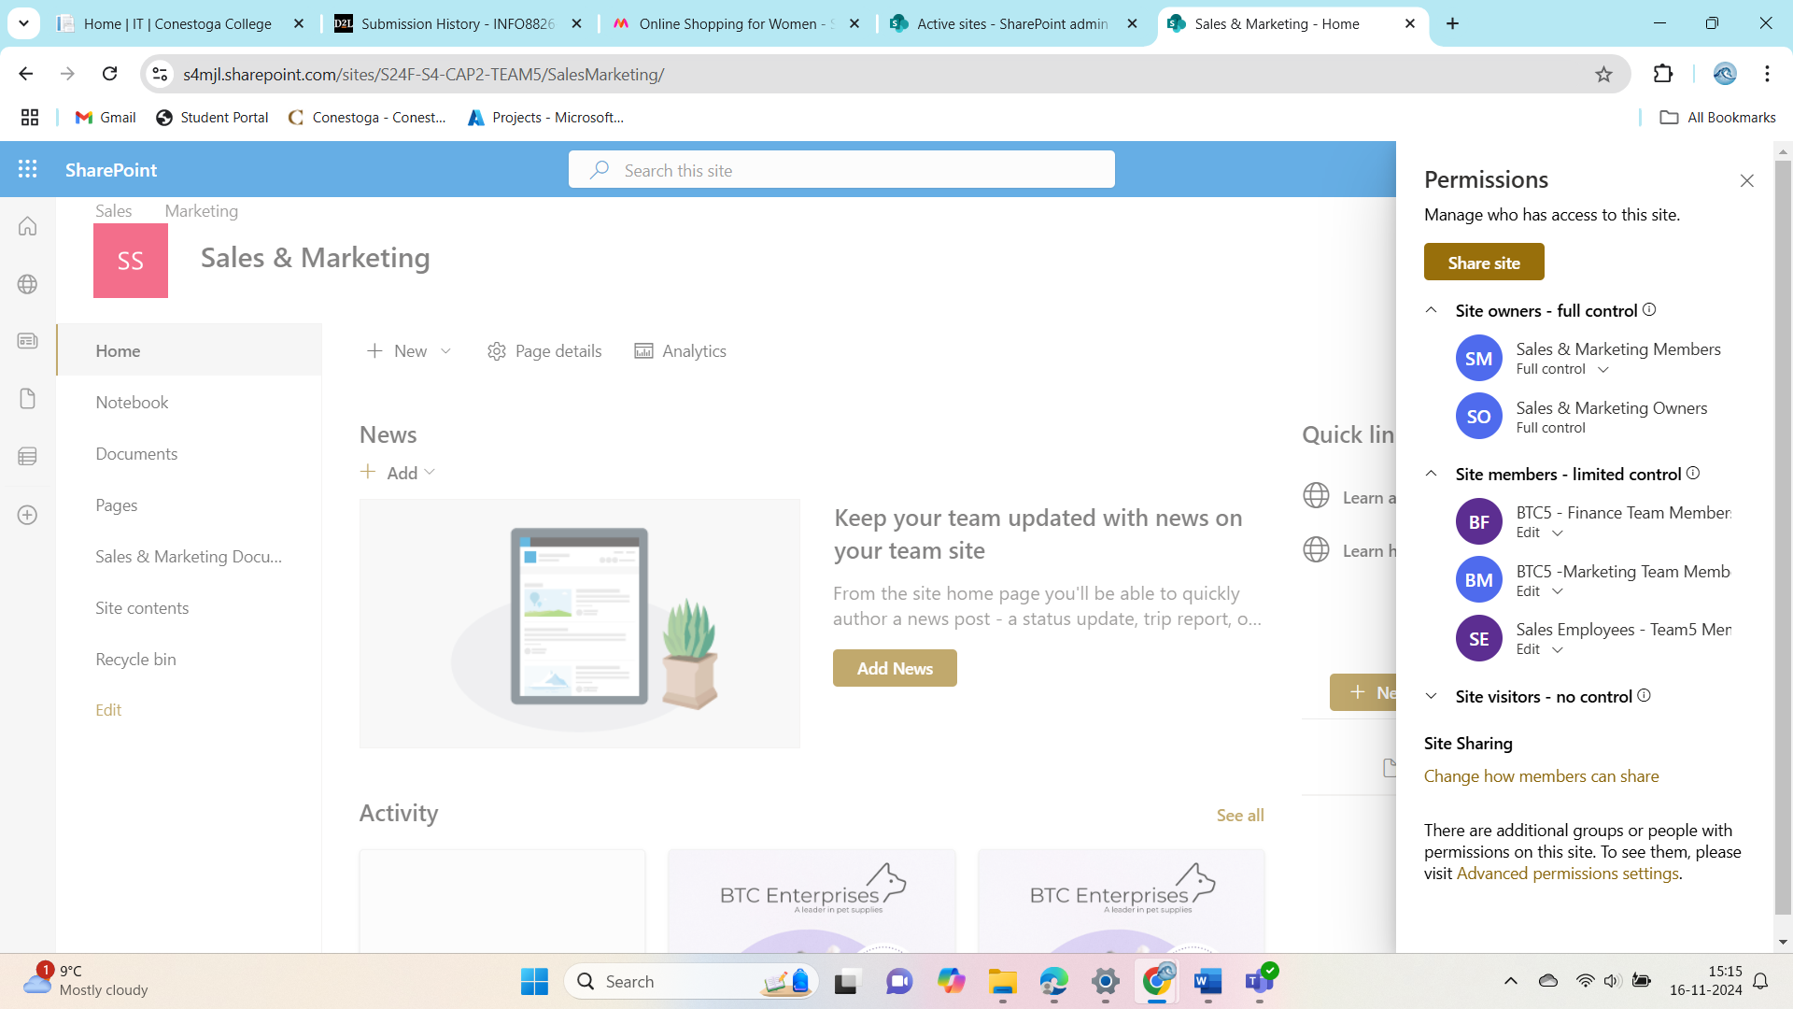

Figure 10 sales and Marketing page site permissions

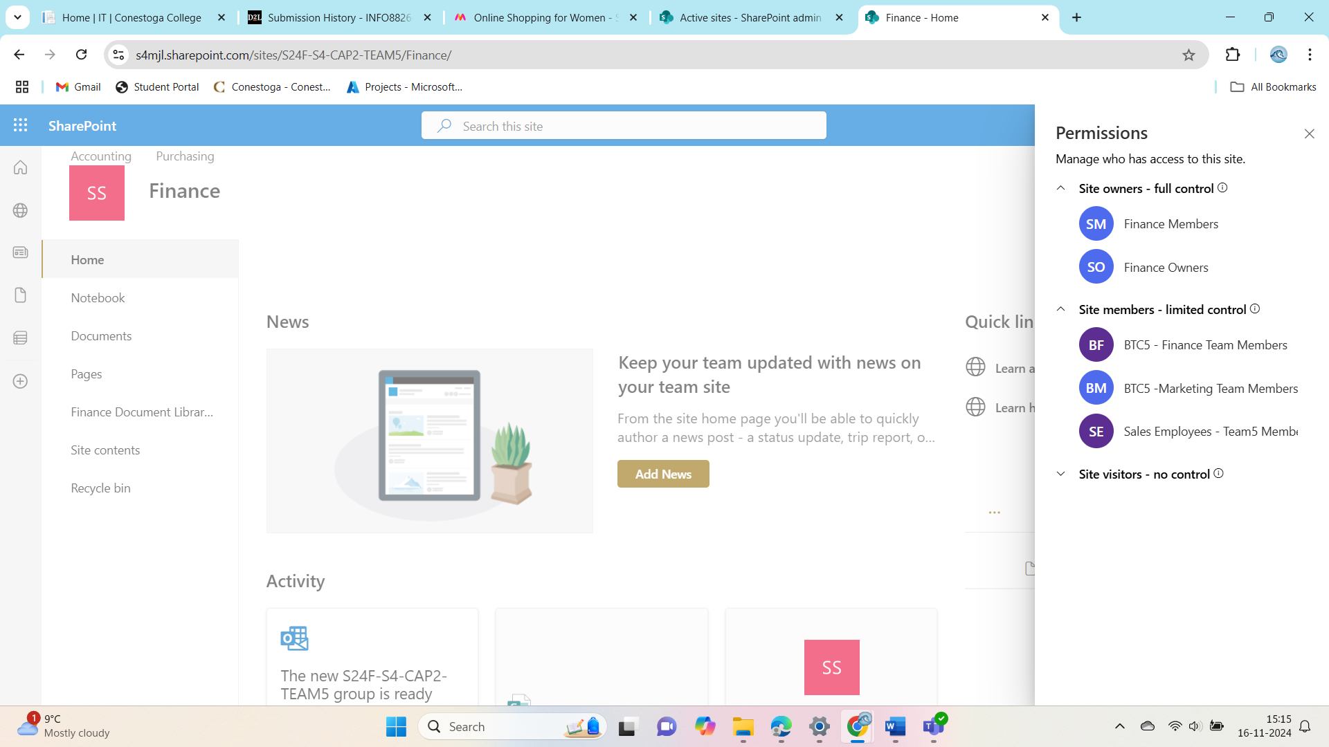

Figure 11 Finance page site permissions

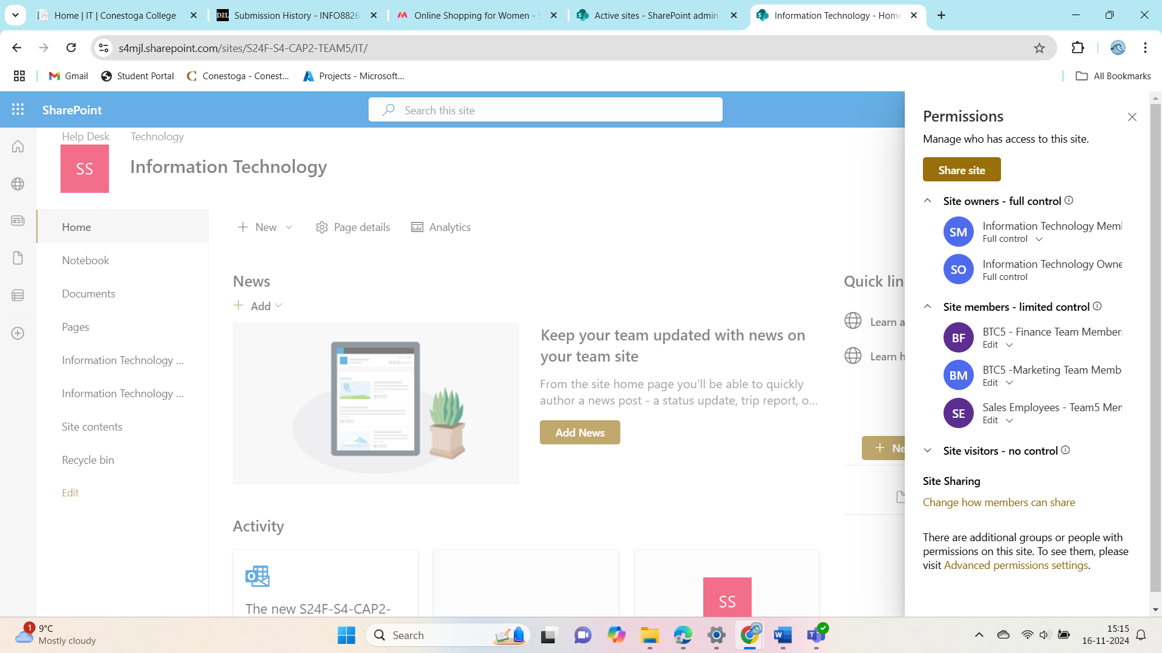

Figure 12 Information page site permissions

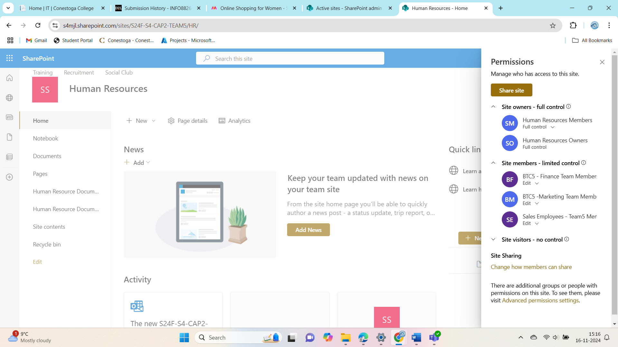

Figure 13 Human Resources page site permissions

# Document Libraries

**Identify the Problem:**  
We’ll check which site, or sub-site has the missing or misconfigured library and confirm its purpose with the relevant department.

**Fix or Add the Library:**  
If it’s missing, we’ll create it based on the department’s requirements, ensuring it’s organized properly. If it’s there but not working as it should, we’ll update the settings and structure.

**Set Permissions:**  
We’ll ensure the right people have access to the library and secure any sensitive data appropriately.

**Test and Confirm:**  
Once the library is set up, we’ll test it to make sure it works as expected and check with the department to ensure it meets their needs.

**Update Documentation:**  
We’ll update any documents to reflect the changes and provide instructions to the department for managing the library.

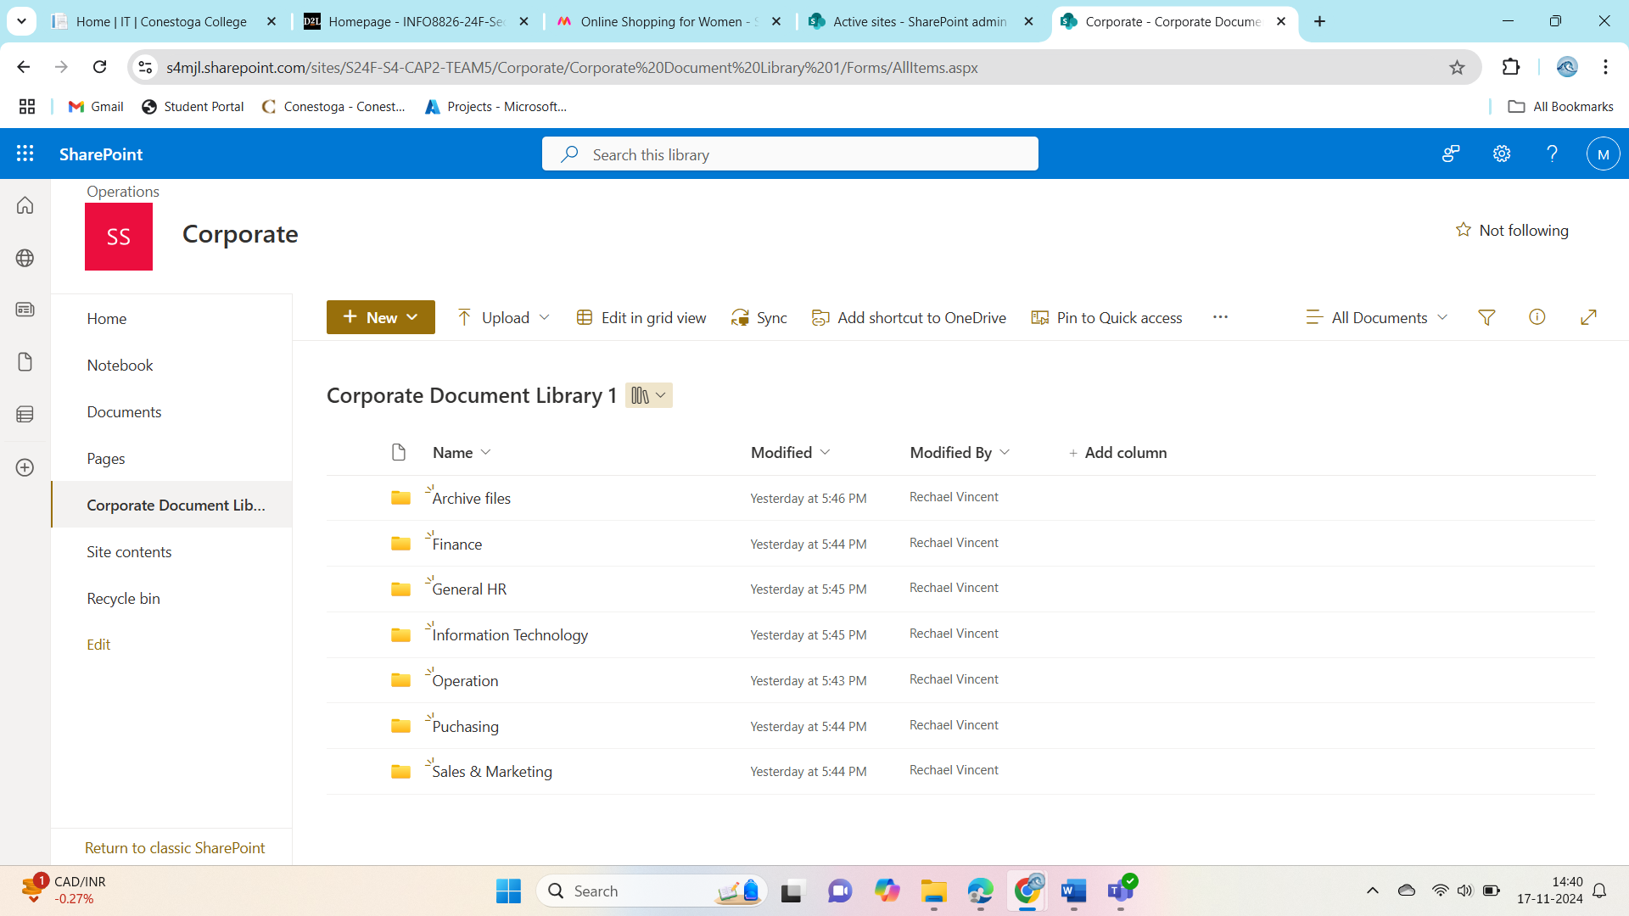

Figure 14 Corporate Document Library

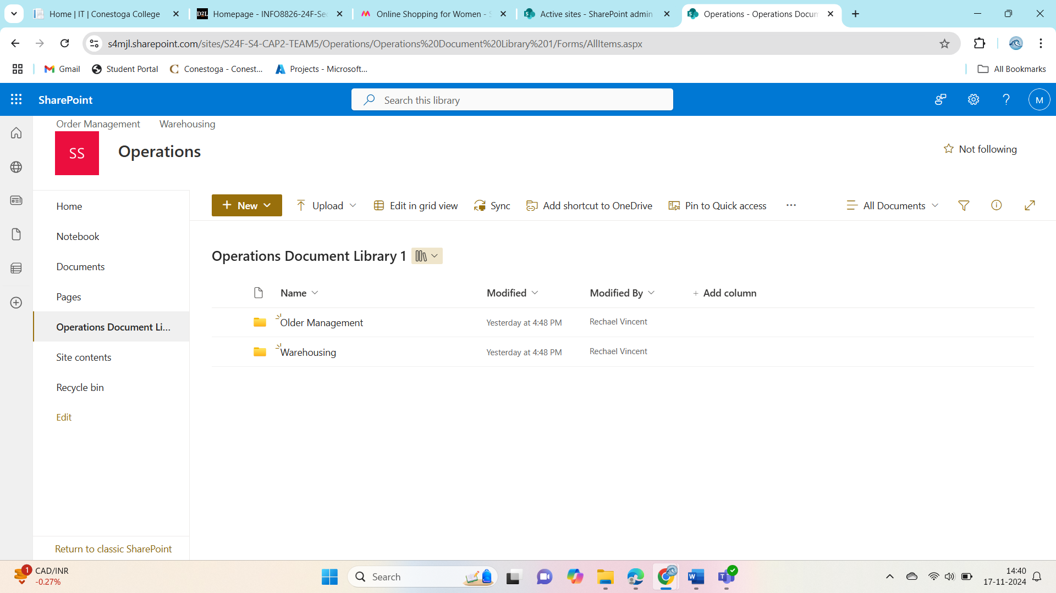

Figure 15 Operations Document Library 1

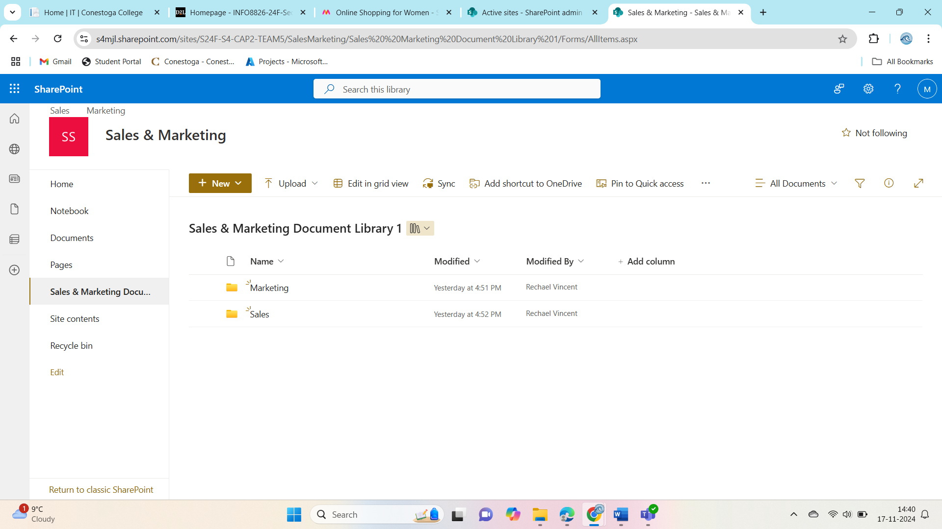

Figure 16 sales and Marketing Document Library 1

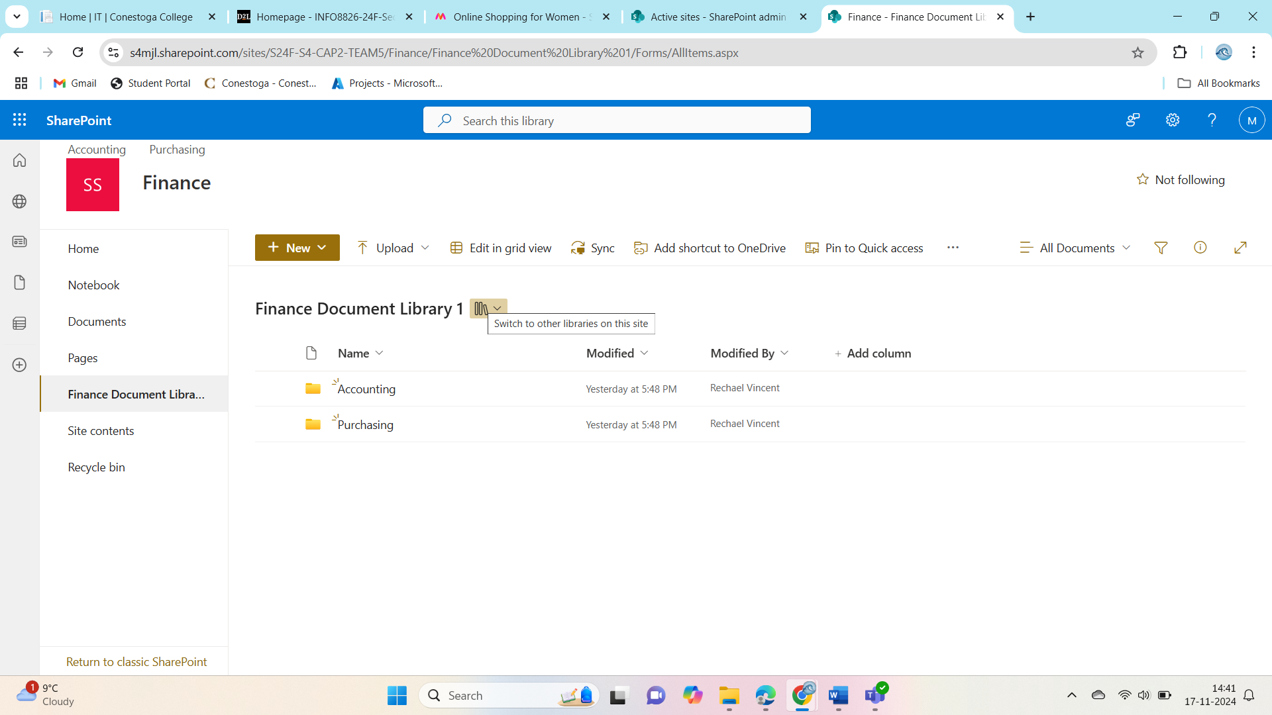

Figure 17 Finance Document Library 1

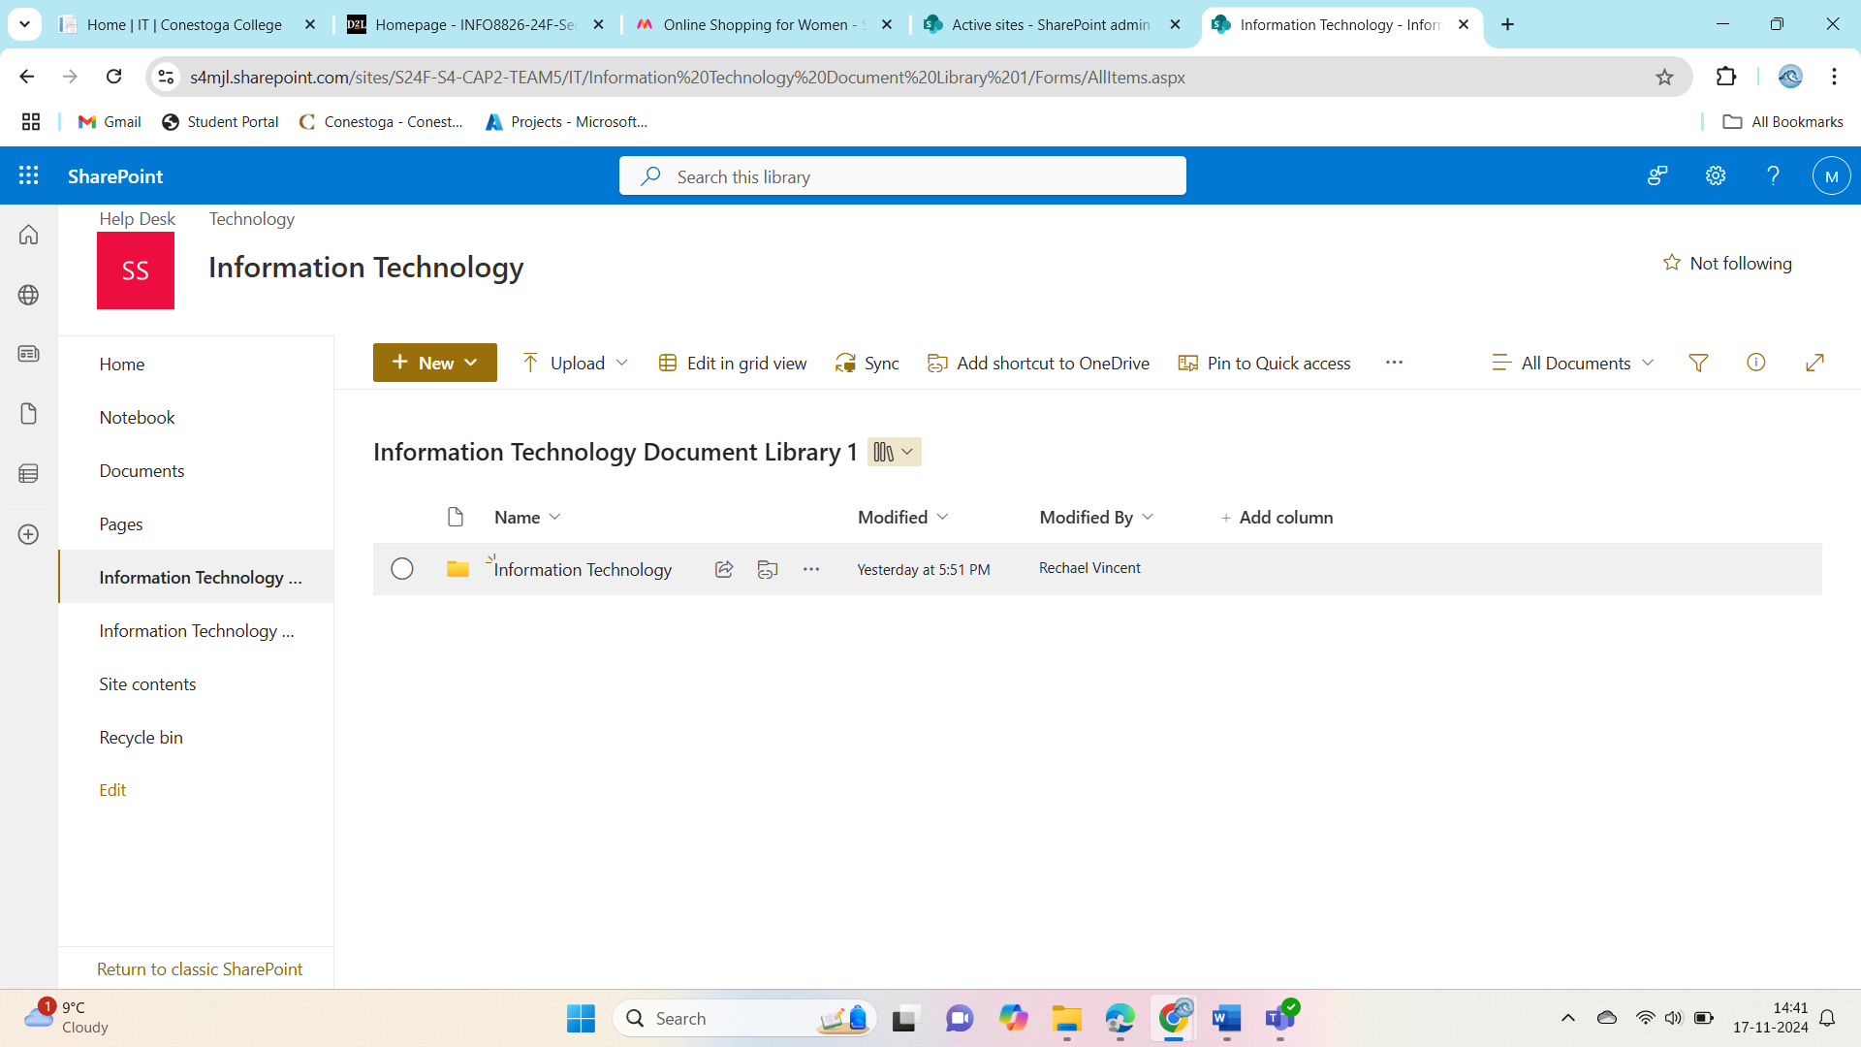

Figure 18 Information Technology document Library 1

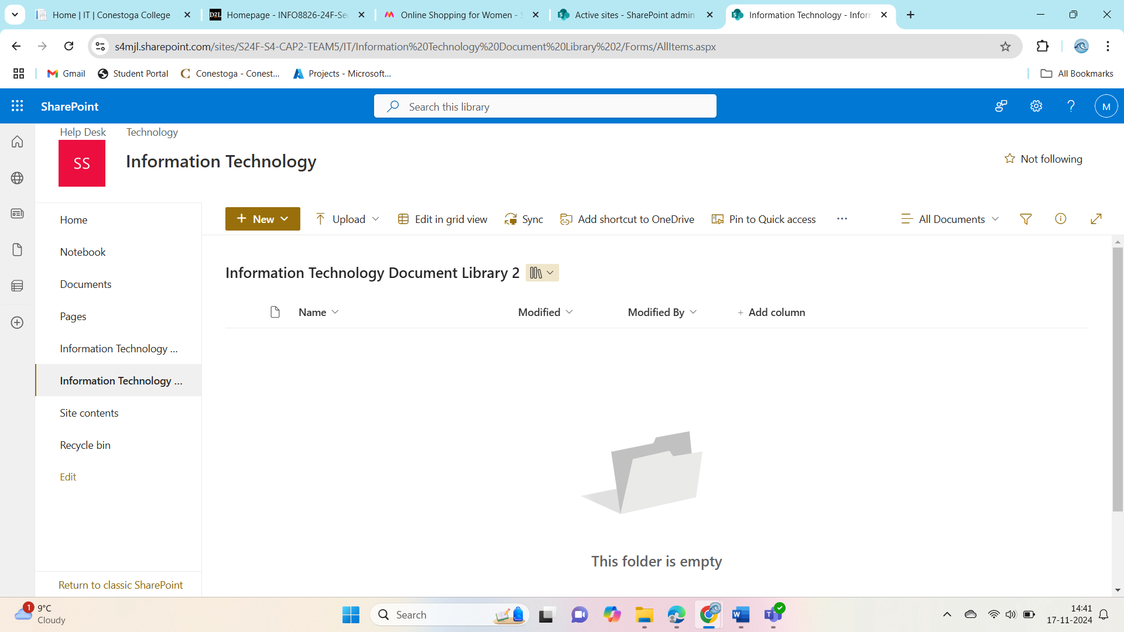

Figure 19 Information Technology Document Library 2

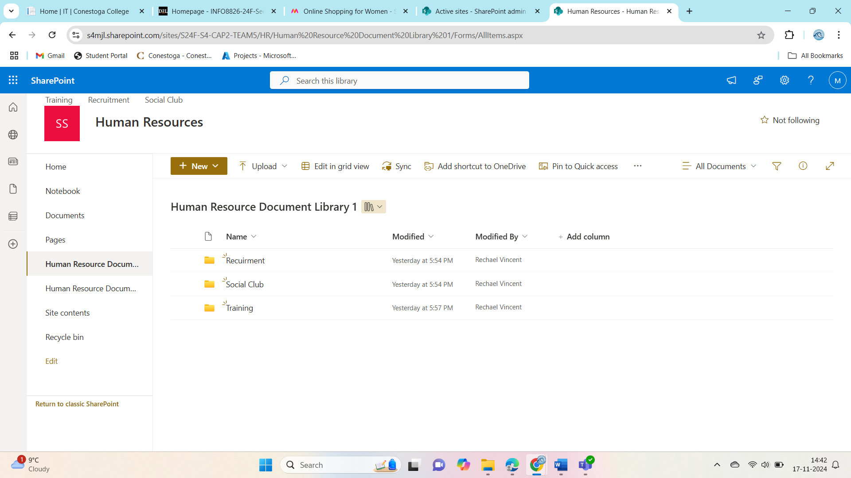

Figure 20 Human Resource Document Library 1

# Document Library Security

All permissions for the top-level site and sub-sites have been identified and assigned correctly. However, we discovered one site or sub-site where the permissions were incomplete or not set as required. We have now reviewed and provided the appropriate permissions to resolve this issue.

**Steps Taken to Address Permissions:**

1. **Identified Issues:**  
   We carefully reviewed the permissions across all sites and identified the one with incomplete or incorrect access settings.
2. **Corrected Permissions:**  
   The necessary permissions were updated to ensure the right users and groups have appropriate access levels, including read, edit, or restricted access as required.
3. **Validated Changes:**  
   We tested the updated permissions to confirm they work correctly, ensuring data security and proper accessibility for all teams.
4. **Informed Stakeholders:**  
   We communicated the changes to the relevant teams and confirmed that the permissions align with their needs.
5. **Updated Records:**  
   All permission-related documentation has been updated to reflect the changes, providing a clear reference for future use.

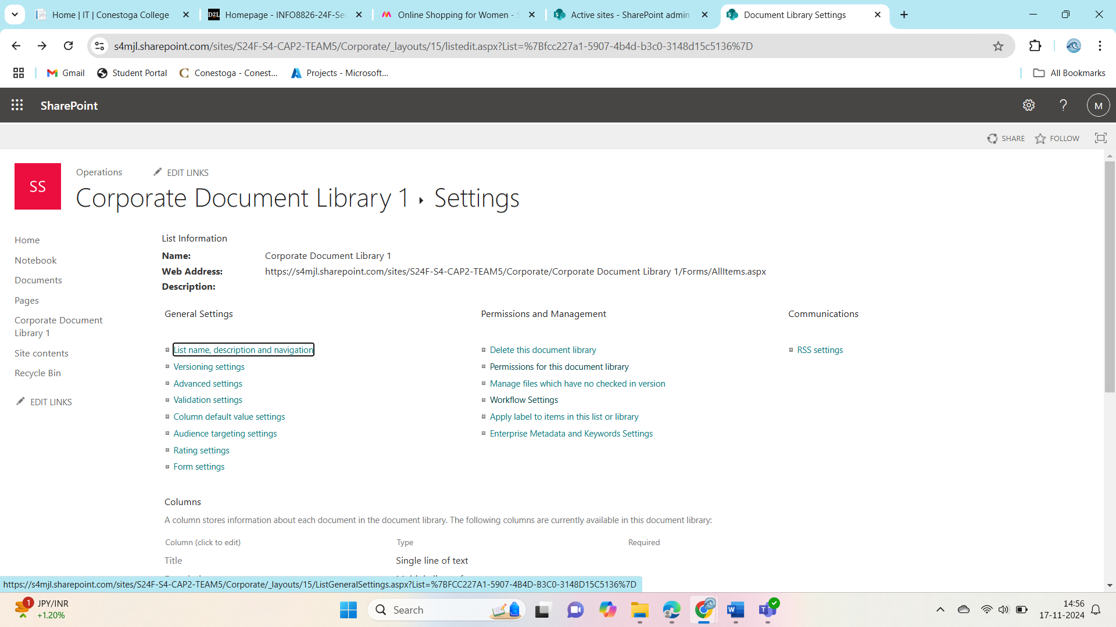

Figure 21 Corporate Document Library settings

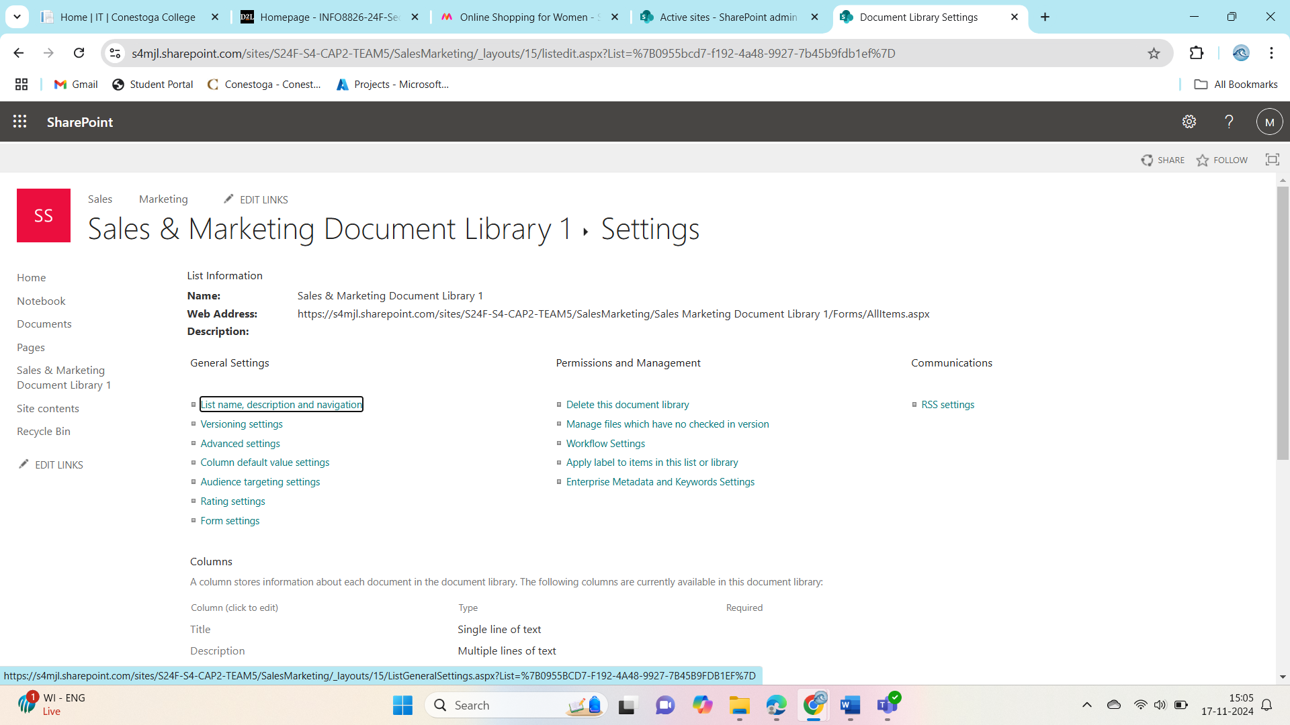

Figure 22 sales and Market Document Library settings

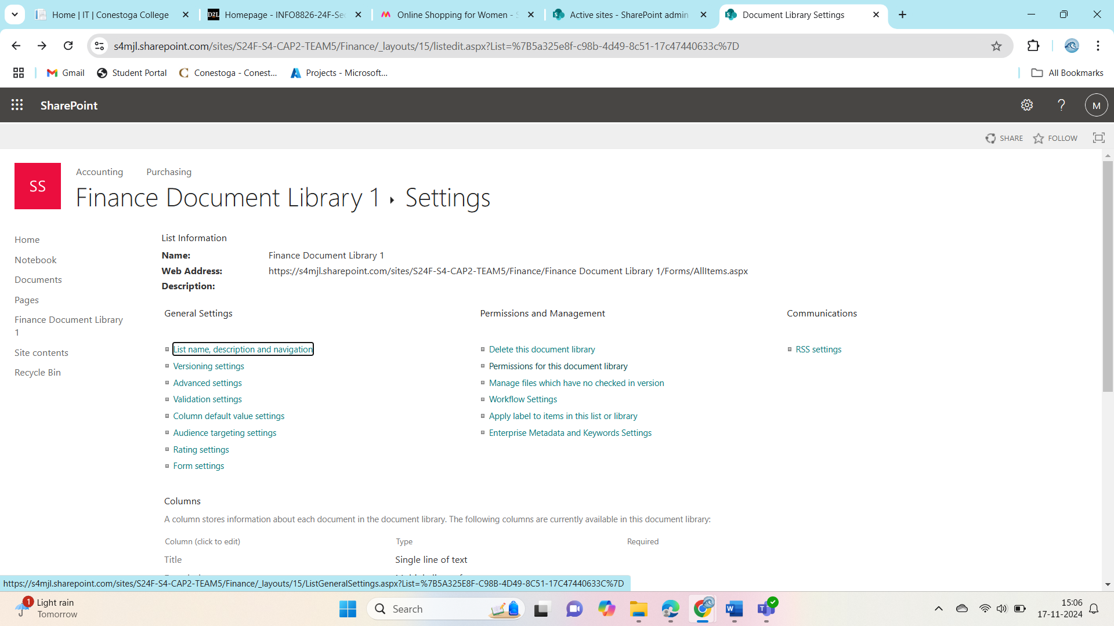

Figure 23 Finance Document Library settings

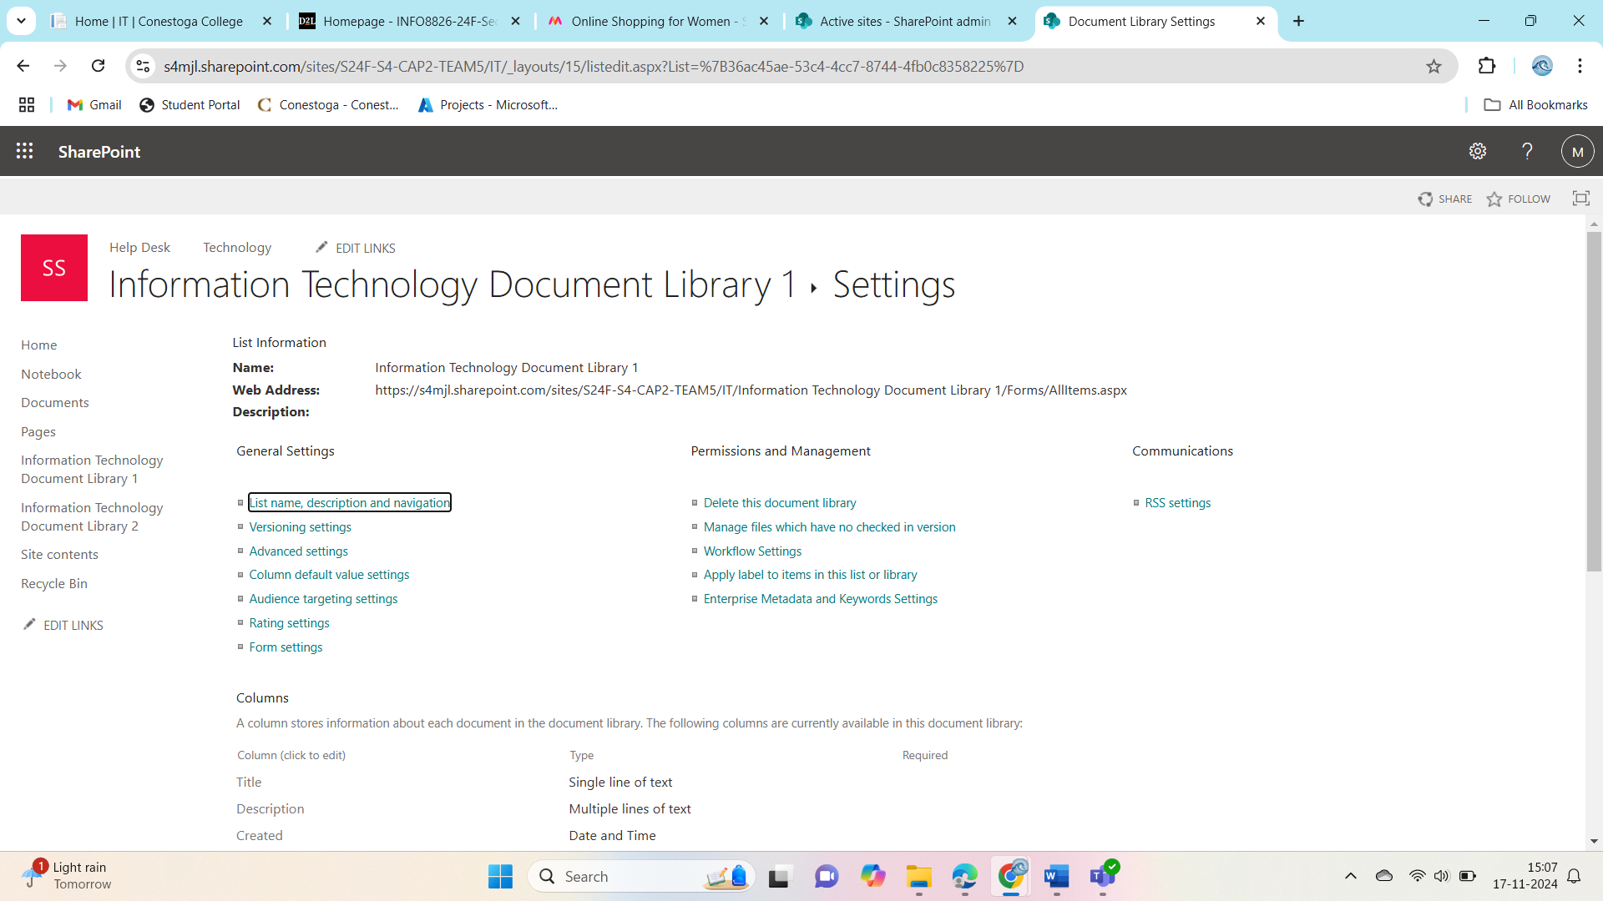

Figure 24 Information Technology Document Library settings

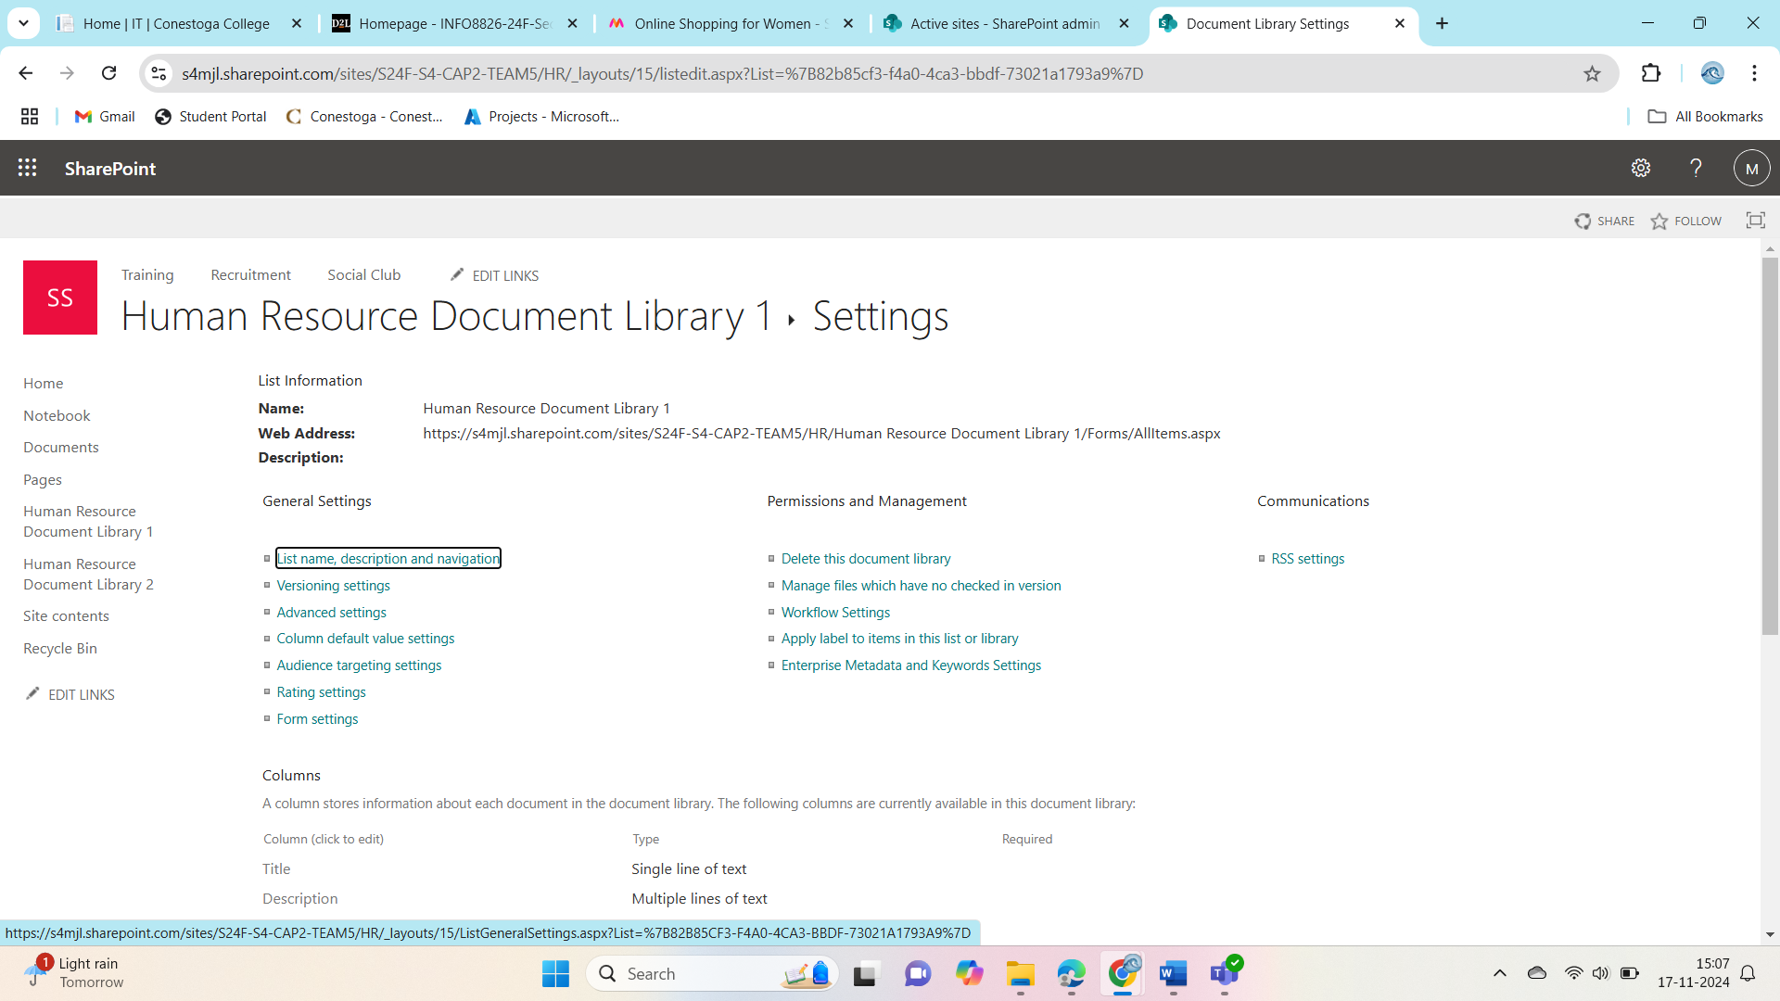

Figure 25 Human Resource Document Library

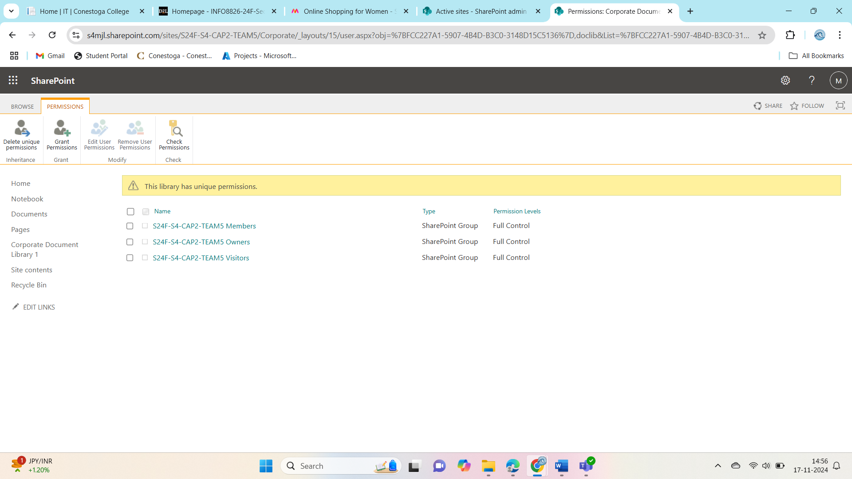

Figure 26 Permissions has been granted as shown

# First Migration

The content migration has been documented in a table with key details such as locations, file types, and comments. However, we identified missing information for the **Corporate**, **Finance**, and **Information Technology** sections.

**Steps Taken to Address Missing Details:**

1. **Identified Missing Details:**  
   We reviewed the migration process and identified the undocumented files for Corporate, Finance, and IT departments.
2. **Updated the Table:**  
   The table has now been updated to include:
   * **Corporate:** Files like internal announcements and company updates, with their locations, file types, and SharePoint destinations.
   * **Finance:** Financial statements and reports, documenting their source folders and SharePoint libraries.
   * **Information Technology:** Technical documentation and IT-related resources, noting their migration status and target locations.
3. **Verified Data:**  
   Each entry was cross-checked with the migration plan to ensure accuracy and completeness.
4. **Finalized Documentation:**  
   The updated table has been saved and shared with stakeholders for validation. It now reflects a complete record of the migrated content.

|  |  |  |  |  |  |
| --- | --- | --- | --- | --- | --- |
| **File Name** | **File Type** | **Destination** | **Comment** | **Action** | **Migrate?** |
| Archive Files | Folder | BTC Enterprise/Corporate | Original | Migrate | Yes |
| Finances | Folder | BTC Enterprise/Corporate | Original | Migrate | Yes |
| Human Resource | Folder | BTC Enterprise/Corporate | Original | Migrate | Yes |
| Information Technology | Folder | BTC Enterprise/Corporate | Original | Migrate | Yes |
| Operations | Folder | BTC Enterprise/Corporate | Original | Migrate | Yes |
| Purchasing | Folder | BTC Enterprise/Corporate | Original | Migrate | Yes |
| Sales & Marketing | Folder | BTC Enterprise/Corporate | Original | Migrate | Yes |
| Bank Statement 83 | .xlsx | BTC Enterprise/Finance/Accounting/Accounting 1 | Original | Migrate | Yes |
| Bank Statement 84 | .xlsx | BTC Enterprise/Finance/Accounting/Accounting 1 | Original | Migrate | Yes |
| Bank Statement 85 | .xlsx | BTC Enterprise/Finance/Accounting/Accounting 1 | Original | Migrate | Yes |
| Bank Statement 86 | .xlsx | BTC Enterprise/Finance/Accounting/Accounting 1 | Original | Migrate | Yes |
| Bank Statement 87 | .xlsx | BTC Enterprise/Finance/Accounting/Accounting 1 | Original | Migrate | Yes |
| Bank Statement 88 | .xlsx | BTC Enterprise/Finance/Accounting/Accounting 1 | Original | Migrate | Yes |
| Bank Statement 89 | .xlsx | BTC Enterprise/Finance/Accounting/Accounting 1 | Original | Migrate | Yes |
| Bank Statement 90 | .xlsx | BTC Enterprise/Finance/Accounting/Accounting 1 | Original | Migrate | Yes |
| Bank Statement 91 | .xlsx | BTC Enterprise/Finance/Accounting/Accounting 1 | Original | Migrate | Yes |
| Bank Statement 92 | .xlsx | BTC Enterprise/Finance/Accounting/Accounting 1 | Original | Migrate | Yes |
| Bank Statement 93 | .xlsx | BTC Enterprise/Finance/Accounting/Accounting 1 | Original | Migrate | Yes |
| Bank Statement 94 | .xlsx | BTC Enterprise/Finance/Accounting/Accounting 1 | Original | Migrate | Yes |
| Bank Statement 95 | .xlsx | BTC Enterprise/Finance/Accounting/Accounting 1 | Original | Migrate | Yes |
| Bank Statement 96 | .xlsx | BTC Enterprise/Finance/Accounting/Accounting 1 | Original | Migrate | Yes |
| Bank Statement 97 | .xlsx | BTC Enterprise/Finance/Accounting/Accounting 1 | Original | Migrate | Yes |
| Bank Statement 98 | .xlsx | BTC Enterprise/Finance/Accounting/Accounting 1 | Original | Migrate | Yes |
| Bank Statement 99 | .xlsx | BTC Enterprise/Finance/Accounting/Accounting 1 | Original | Migrate | Yes |
| Bank Statement 100 | .xlsx | BTC Enterprise/Finance/Accounting/Accounting 1 | Original | Migrate | Yes |
| Bank Statement 103 | .xlsx | BTC Enterprise/Finance/Accounting/Accounting 19 | Original | Migrate | Yes |
| Bank Statement 104 | .xlsx | BTC Enterprise/Finance/Accounting/Accounting 1 | Original | Migrate | Yes |
| Bank Statement 109 | .xlsx | BTC Enterprise/Finance/Accounting/Accounting 1 | Original | Migrate | Yes |
| Bank Statement 111 | .xlsx | BTC Enterprise/Finance/Accounting/Accounting 1 | Original | Migrate | Yes |
| Bank Statement 115 | .xlsx | BTC Enterprise/Finance/Accounting/Accounting 1 | Original | Migrate | Yes |
| Bank Statement 120 | .xlsx | BTC Enterprise/Finance/Accounting/Accounting 1 | Original | Migrate | Yes |
| Bank Statement 121 | .xlsx | BTC Enterprise/Finance/Accounting/Accounting 2 | Original | Migrate | Yes |
| Invoice 1654 | .docx | BTC Enterprise/Finance/Accounting/Accounting 2 | Original | Migrate | Yes |
| Invoice 1999 | .docx | BTC Enterprise/Finance/Accounting/Accounting 2 | Original | Migrate | Yes |
| Invoice 2301 | .docx | BTC Enterprise/Finance/Accounting/Accounting 2 | Original | Migrate | Yes |
| Invoice 2301 | .docx | BTC Enterprise/Finance/Accounting/Accounting 2 | Original | Migrate | Yes |
| Invoice 1034 | .docx | BTC Enterprise/Finance/Accounting/Accounting 2 | Original | Migrate | Yes |
| Invoice 1041 | .docx | BTC Enterprise/Finance/Accounting/Accounting 2 | Original | Migrate | Yes |
| Invoice 1042 | .docx | BTC Enterprise/Finance/Accounting/Accounting 2 | Original | Migrate | Yes |
| PO96999 | .docx | BTC Enterprise/Finance/Purchasing |  | Migrate | Yes |
| PO97991 | .docx | BTC Enterprise/Finance/Purchasing |  | Migrate | Yes |
| PO97992 | .docx | BTC Enterprise/Finance/Purchasing |  | Migrate | Yes |
| PO98009 | .docx | BTC Enterprise/Finance/Purchasing |  | Migrate | Yes |
| PO98087 | .docx | BTC Enterprise/Finance/Purchasing |  | Migrate | Yes |
| PO90210 | .docx | BTC Enterprise/Purchasing | Original | Migrate | Yes |
| PO91104 | .docx | BTC Enterprise/Purchasing | Original | Migrate | Yes |
| PO91109 | .docx | BTC Enterprise/Purchasing | Original | Migrate | Yes |
| PO91255 | .docx | BTC Enterprise/Purchasing | Original | Migrate | Yes |
| PO91319 | .docx | BTC Enterprise/Purchasing | Original | Migrate | Yes |
| PO91708 | .docx | BTC Enterprise/Purchasing | Original | Migrate | Yes |
| PO91710 | .docx | BTC Enterprise/Purchasing | Original | Migrate | Yes |
| PO91769 | .docx | BTC Enterprise/Purchasing | Original | Migrate | Yes |
| PO91899 | .docx | BTC Enterprise/Purchasing | Original | Migrate | Yes |
| PO96999 | .docx | BTC Enterprise/Purchasing | Original | Migrate | Yes |
| PO97991 | .docx | BTC Enterprise/Purchasing | Original | Migrate | Yes |
| PO97992 | .docx | BTC Enterprise/Purchasing | Original | Migrate | Yes |
| PO98009 | .docx | BTC Enterprise/Purchasing | Original | Migrate | Yes |
| PO98087 | .docx | BTC Enterprise/Purchasing | Original | Migrate | Yes |
| PO98116 | .docx | BTC Enterprise/Purchasing | Original | Migrate | Yes |
| PO98119 | .docx | BTC Enterprise/Purchasing | Original | Migrate | Yes |
| PO98120 | .docx | BTC Enterprise/Purchasing | Original | Migrate | Yes |
| PO98121 | .docx | BTC Enterprise/Purchasing | Original | Migrate | Yes |
| BTC Enterprise-logo-black | .png | BTC Enterprise/Information Technology/Help Desk | Original | Migrate | Yes |
| BTC Enterprise-logo-white | .png | BTC Enterprise/Information Technology/Help Desk | Original | Migrate | Yes |
| dog039sonly.WordPress.2022-10-19 | .xml | BTC Enterprise/Information Technology/Technology | Original | Migrate | Yes |

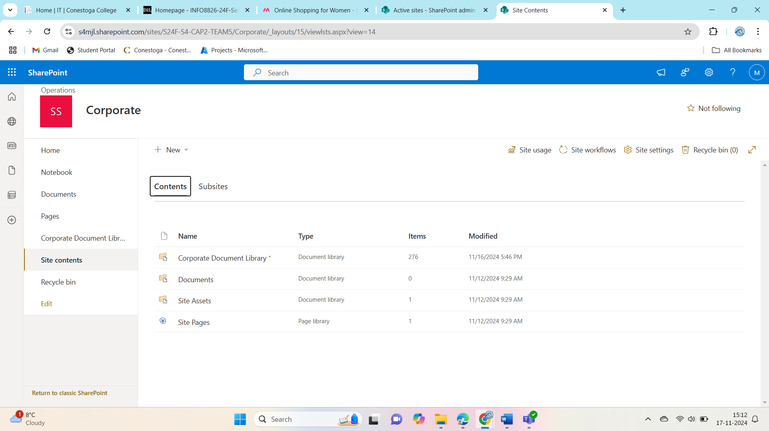

Figure 27 content migrated for Corporate Library

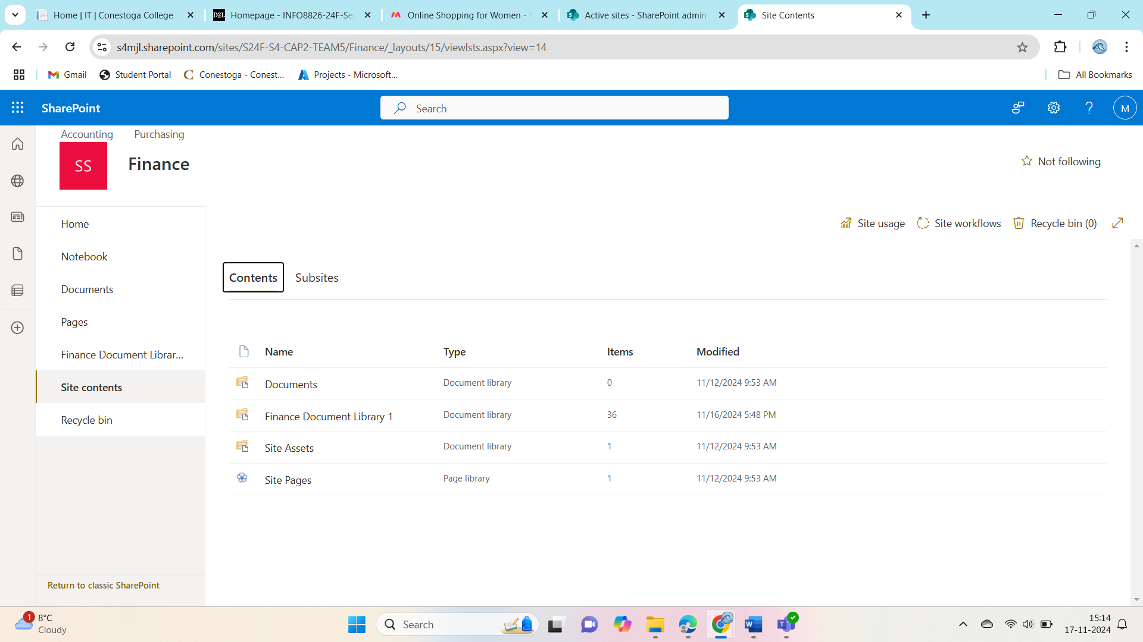

Figure 28 Content Migrated for Finance Folder

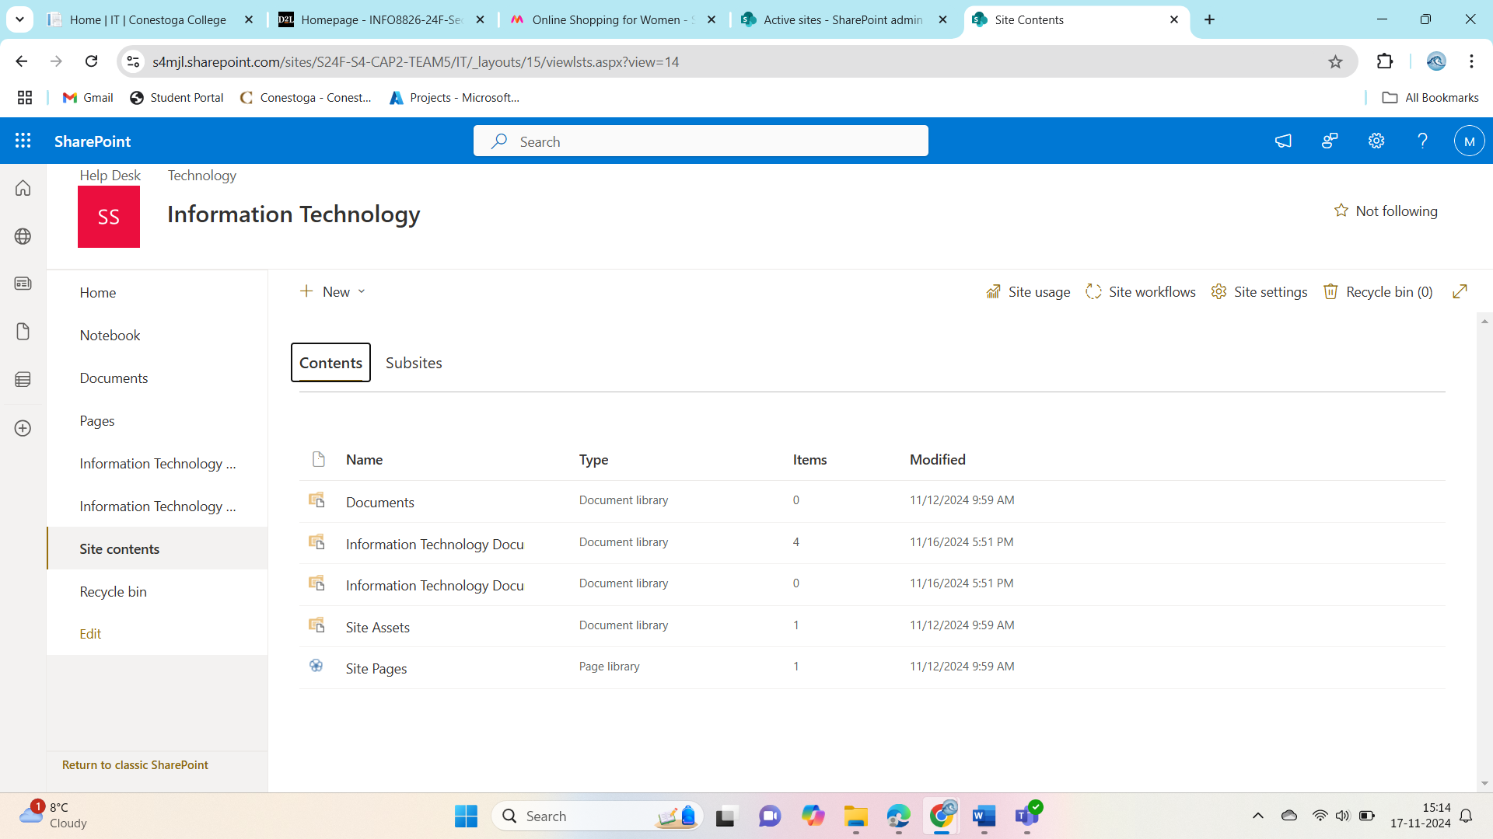

Figure 29 Content Migrated for Information Technology folder

# First Migration Documentation

**First Migration Documentation**

The first migration phase involved transferring various departmental content to SharePoint, ensuring that files were properly classified and organized. The migrated content is documented in a table, which includes details such as file locations, file types, and additional comments about the content. However, two key details for the **Corporate**, **Finance**, and **Information Technology** sections are missing, which we are addressing to complete the documentation.

**Migration Overview:**

1. **Migration Process:**  
   The content migration was carried out in a systematic approach, starting with high-priority data from the **Finance**, **HR**, and **IT** departments. Files from other departments, such as **Marketing** and **Operations**, were also migrated during this phase. Each file was reviewed for relevance, accuracy, and completeness before being transferred to the appropriate SharePoint libraries.
2. **Documented Content:**  
   A table was created to document the migrated content, which includes:
   * **File Name:** The name of the file that was migrated.
   * **Location:** The original location of the file in the current system.
   * **File Type:** The file format (e.g., .docx, .xlsx, .pdf).
   * **Destination:** The SharePoint site or document library where the file was moved.
   * **Comments:** Any additional information regarding the file (e.g., specific instructions or special handling).
3. **Missing Details:**  
   For the **Corporate**, **Finance**, and **IT** departments, two key details were missing from the documentation:
   * The **specific file names** that were migrated for these departments.
   * The **SharePoint destination** (or library name) for some files, particularly where files were categorized under generic labels or not fully mapped.

**Next Steps to Complete the Documentation:**

1. **Identify Missing Details:**  
   We will review the migration process for the Corporate, Finance, and IT departments to identify the specific files that were not fully documented.
2. **Update the Table:**  
   The missing details (file names and SharePoint destinations) will be added to the table, ensuring all migrated content is fully accounted for.
3. **Validate Accuracy:**  
   We will confirm the updated table matches the migration plan and that all information is correct before finalizing the documentation.
4. **Final Documentation:**  
   Once the missing details are added and validated, the updated table will be shared with stakeholders for review, and the migration documentation will be finalized.

# Second Migration

This is the phase where we concentrate on moving new and changed material over to our SharePoint system. For instance, then we could transfer new files and changed documents that did not get transferred in the first migration. Below are some screenshots that prove visual evidence of the transfer and arrangement of these processes.

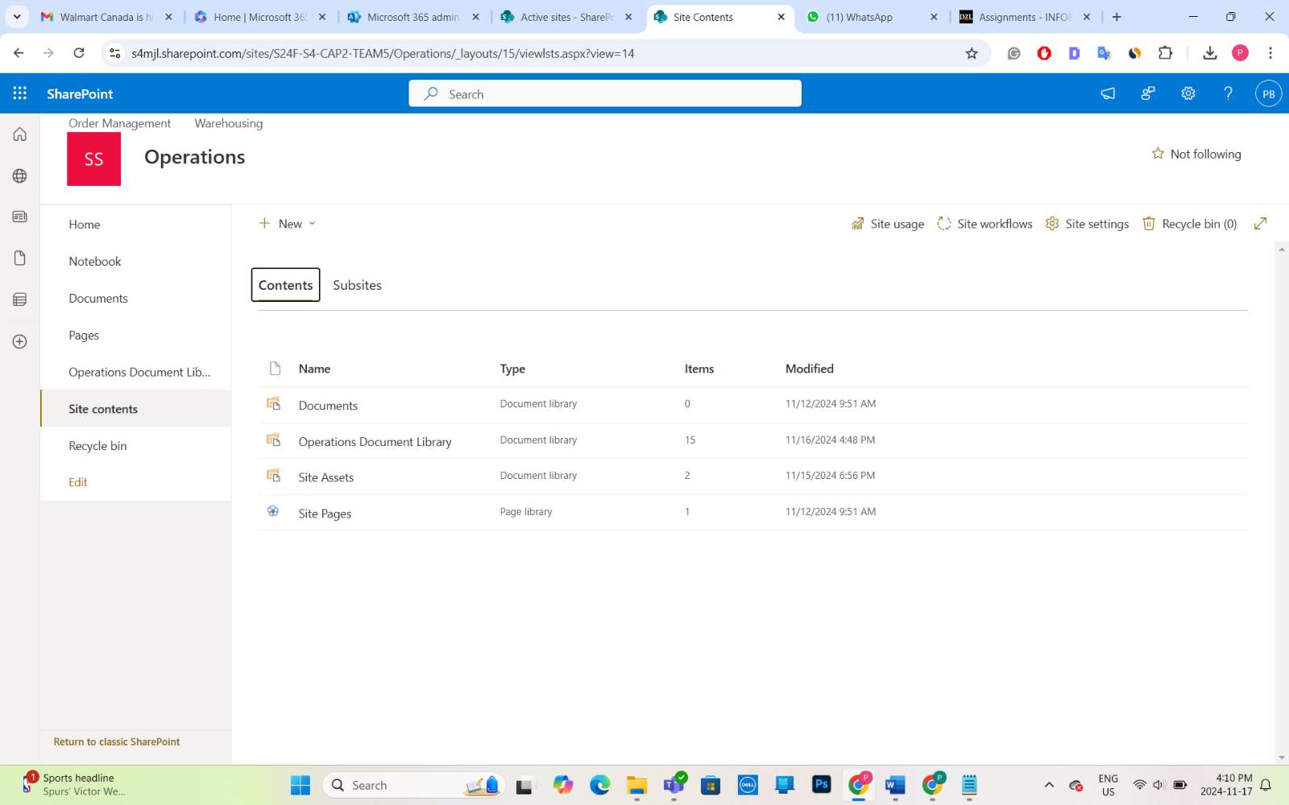Figure 30 - Content Migrated for Operations

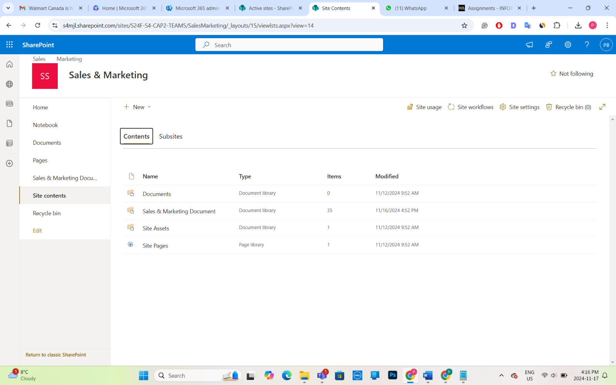Figure 31 Content Migrated for Sales & Marketing

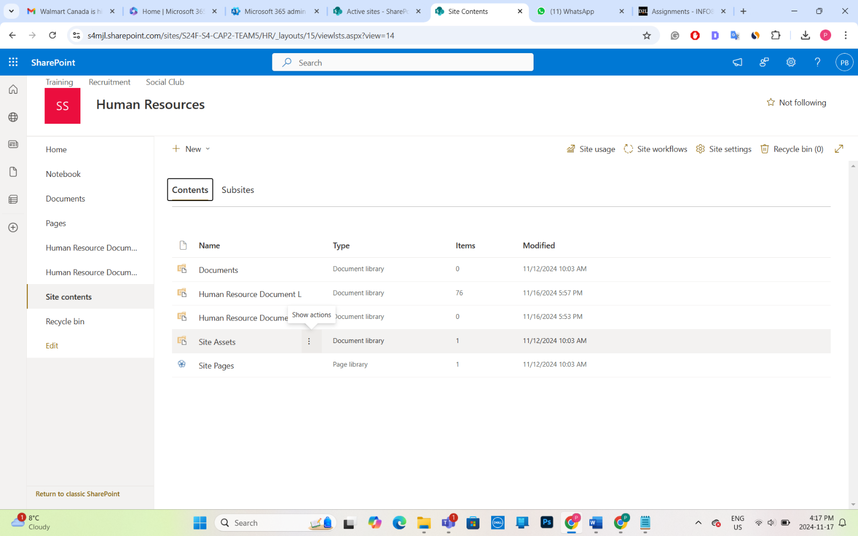Figure 32 Content Migrated for Human Resources

# Second Migration Documentation

Steps that took during Second Migration

Requirement Analysis:

* After reviewing client feedback from previous meetings it was determined additional file types and folders were to be migrated.
* Into the migration plan were incorporated department-specific needs including customized library views and workflow automation.

Content Transfer:

* On a gradual basis, files were slowly moved from the places they came from to the SharePoint libraries.
* Sensitive data such as financial reports and HR records were given special attention, so that security settings were correct.

File Verification:

* Files were reviewed for accuracy and placement post migration.
* Restricted access was guaranteed by revalidating permissions.

Documentation:

* As evidence of a successful migration, screenshots were taken.
* A table was made to keep track of the files that were migrated in a comprehensive manner.

|  |  |  |  |  |  |
| --- | --- | --- | --- | --- | --- |
| **File Name** | **File Type** | **Destination** | **Comment** | **Action** | **Migrated?** |
| COVID-19 Screening | .docx | BTC Enterprise/Operations/Older Management | Original | Migrate | Yes |
| COVID-19 Screening | .docx | BTC Enterprise/Operations/Older Management | Original | Migrate | Yes |
| Loading Dock Operation | .docx | BTC Enterprise/Operations/Older Management | Original | Migrate | Yes |
| Onboarding SOP | .docx | BTC Enterprise/Operations/Older Management | Original | Migrate | Yes |
| Packing Amazon Orders | .docx | BTC Enterprise/Operations/Older Management | Original | Migrate | Yes |
| Packing Pet Smart Orders (OLD) | .docx | BTC Enterprise/Operations/Older Management | Original | Migrate | Yes |
| Packing Pet Smart Orders | .docx | BTC Enterprise/Operations/Older Management | Original | Migrate | Yes |
| Pet Food Manufacturing | .docx | BTC Enterprise/Operations/Older Management | Original | Migrate | Yes |
| Pet Suppiler SOP | .docx | BTC Enterprise/Operations/Older Management | Original | Migrate | Yes |
| Safety SOP | .docx | BTC Enterprise/Operations/Older Management | Older than 7 years | Archive | Yes |
| Warehouse Dresscode Copy | .docx | BTC Enterprise/Operations/Warehouse | Original | Migrate | Yes |
| Warehouse Shelvinh | .docx | BTC Enterprise/Operations/Warehouse | Original | Migrate | Yes |
| Invoice 1801 | .docx | BTC Enterprise/Sales & Marketing/Sales | Original | Migrate | Yes |
| Invoice 1843 | .docx | BTC Enterprise/Sales & Marketing/Sales | Original | Migrate | Yes |
| Invoice 1876 | .docx | BTC Enterprise/Sales & Marketing/Sales | Original | Migrate | Yes |
| Sales Procedure Guidelines | .docx | BTC Enterprise/Sales & Marketing/Sales | Original | Migrate | Yes |
| Sales Procedure Template | .docx | BTC Enterprise/Sales & Marketing/Sales | Original | Migrate | Yes |
| Adopt a Cat Day Promo | .png | BTC Enterprise/Sales & Marketing/Marketing | Original | Migrate | Yes |
| Bulk Orders Promotion | .png | BTC Enterprise/Sales & Marketing/Marketing | Original | Migrate | Yes |
| Cat Flyer-1 | .png | BTC Enterprise/Sales & Marketing/Marketing | Original | Migrate | Yes |
| Cat Flyer-2 | .png | BTC Enterprise/Sales & Marketing/Marketing | Original | Migrate | Yes |
| Cat Flyer-3 | .png | BTC Enterprise/Sales & Marketing/Marketing | Original | Migrate | Yes |
| Cat Litter Sale Flyer | .png | BTC Enterprise/Sales & Marketing/Marketing | Original | Migrate | Yes |
| Cat Treats Manufacturers Coupon | .png | BTC Enterprise/Sales & Marketing/Marketing | Original | Migrate | Yes |
| Dog Bed Coupon Flyer | .png | BTC Enterprise/Sales & Marketing/Marketing | Original | Migrate | Yes |
| Dog Collar Sale Flyer | .png | BTC Enterprise/Sales & Marketing/Marketing | Original | Migrate | Yes |
| Dog Grooming Discount Flyer | .png | BTC Enterprise/Sales & Marketing/Marketing | Original | Migrate | Yes |
| Flea and Tick Coupon Flyer | .png | BTC Enterprise/Sales & Marketing/Marketing | Original | Migrate | Yes |
| Flyer Template 1 | .png | BTC Enterprise/Sales & Marketing/Marketing | Original | Migrate | Yes |
| Flyer Template-1 | .png | BTC Enterprise/Sales & Marketing/Marketing | Original | Migrate | Yes |
| Flyer Template-2 | .png | BTC Enterprise/Sales & Marketing/Marketing | Original | Migrate | Yes |
| Flyer Template-3(1) | .png | BTC Enterprise/Sales & Marketing/Marketing | Original | Migrate | Yes |
| Flyer Template-3 | .png | BTC Enterprise/Sales & Marketing/Marketing | Original | Migrate | Yes |
| General BTC Marketing | .png | BTC Enterprise/Sales & Marketing/Marketing | Original | Migrate | Yes |
| Manufacturers Coupon_Mailout Flyer Final | .png | BTC Enterprise/Sales & Marketing/Marketing | Original | Migrate | Yes |
| Multi Pet Flyer-1 | .png | BTC Enterprise/Sales & Marketing/Marketing | Original | Migrate | Yes |
| Small Pet Supplies Flyer | .png | BTC Enterprise/Sales & Marketing/Marketing | Original | Migrate | Yes |
| Untitled document | .png | BTC Enterprise/Sales & Marketing/Marketing | Original | Migrate | Yes |
| Who is BTC | .png | BTC Enterprise/Sales & Marketing/Marketing | Original | Migrate | Yes |
| 1 | .png | BTC Enterprise/Sales & Marketing/Marketing | Original | Migrate | Yes |
| 2 | .png | BTC Enterprise/Sales & Marketing/Marketing | Original | Migrate | Yes |
| Direct Deposit Form | .docx | BTC Enterprise/Human Resource/Recuirment | Original | Migrate | Yes |
| Emergency Information | .docx | BTC Enterprise/Human Resource/Recuirment | Original | Migrate | Yes |
| Employee Perks | .docx | BTC Enterprise/Human Resource/Recuirment | Original | Migrate | Yes |
| Health Benefits Regestration Form | .docx | BTC Enterprise/Human Resource/Recuirment | Original | Migrate | Yes |
| New Hire Checklist | .docx | BTC Enterprise/Human Resource/Recuirment | Original | Migrate | Yes |
| New Hire Form Final | .docx | BTC Enterprise/Human Resource/Recuirment | Original | Migrate | Yes |
| New Hire Form | .docx | BTC Enterprise/Human Resource/Recuirment | Original | Migrate | Yes |
| Donna Retirement | .docx | BTC Enterprise/Human Resource/Social Club | Original | Migrate | Yes |
| Family Day Event | .docx | BTC Enterprise/Human Resource/Social Club | Original | Migrate | Yes |
| Family Movie Night | .docx | BTC Enterprise/Human Resource/Social Club | Original | Migrate | Yes |
| Holiday Party 2018 | .docx | BTC Enterprise/Human Resource/Social Club | Original | Migrate | Yes |
| Holiday Party | .docx | BTC Enterprise/Human Resource/Social Club | Original | Migrate | Yes |
| Meditation Workshop | .docx | BTC Enterprise/Human Resource/Social Club | Original | Migrate | Yes |
| New Members | .docx | BTC Enterprise/Human Resource/Social Club | Original | Migrate | Yes |
| Virtual Holiday Party | .docx | BTC Enterprise/Human Resource/Social Club | Original | Migrate | Yes |
| Thanksgiving Lunch | .docx | BTC Enterprise/Human Resource/Social Club | Original | Migrate | Yes |
| Employee Request - BJ | .docx | BTC Enterprise/Human Reource/Training | Original | Migrate | Yes |
| Employee Request - BP | .docx | BTC Enterprise/Human Reource/Training | Original | Migrate | Yes |
| Employee Request - BR | .docx | BTC Enterprise/Human Reource/Training | Original | Migrate | Yes |
| Employee Request - CB | .docx | BTC Enterprise/Human Reource/Training | Original | Migrate | Yes |
| Employee Request - DB | .docx | BTC Enterprise/Human Reource/Training | Original | Migrate | Yes |
| Employee Request - DJ(1) | .docx | BTC Enterprise/Human Reource/Training | Original | Migrate | Yes |
| Employee Request - DJ | .docx | BTC Enterprise/Human Reource/Training | Original | Migrate | Yes |
| Employee Request - DM | .docx | BTC Enterprise/Human Reource/Training | Original | Migrate | Yes |
| Employee Request - GM | .docx | BTC Enterprise/Human Reource/Training | Original | Migrate | Yes |
| Employee Request - JB | .docx | BTC Enterprise/Human Reource/Training | Original | Migrate | Yes |
| Employee Request - JK | .docx | BTC Enterprise/Human Reource/Training | Original | Migrate | Yes |
| Employee Request - JP | .docx | BTC Enterprise/Human Reource/Training | Original | Migrate | Yes |
| Employee Request - JR(1) | .docx | BTC Enterprise/Human Reource/Training | Original | Migrate | Yes |
| Employee Request - JR | .docx | BTC Enterprise/Human Reource/Training | Original | Migrate | Yes |
| Employee Request - KP | .docx | BTC Enterprise/Human Reource/Training | Original | Migrate | Yes |
| Employee Request - LD | .docx | BTC Enterprise/Human Reource/Training | Original | Migrate | Yes |
| Employee Request - LG | .docx | BTC Enterprise/Human Reource/Training | Original | Migrate | Yes |
| Employee Request - LL | .docx | BTC Enterprise/Human Reource/Training | Original | Migrate | Yes |
| Employee Request - MC | .docx | BTC Enterprise/Human Reource/Training | Original | Migrate | Yes |
| Employee Request - MH(1) | .docx | BTC Enterprise/Human Reource/Training | Original | Migrate | Yes |
| Employee Request - MH | .docx | BTC Enterprise/Human Reource/Training | Original | Migrate | Yes |
| Employee Request - MM | .docx | BTC Enterprise/Human Reource/Training | Original | Migrate | Yes |
| Employee Request - MP(1) | .docx | BTC Enterprise/Human Reource/Training | Original | Migrate | Yes |
| Employee Request - MP | .docx | BTC Enterprise/Human Reource/Training | Original | Migrate | Yes |
| Employee Request - MR | .docx | BTC Enterprise/Human Reource/Training | Original | Migrate | Yes |
| Employee Request - PR | .docx | BTC Enterprise/Human Reource/Training | Original | Migrate | Yes |
| Employee Request - PS | .docx | BTC Enterprise/Human Reource/Training | Original | Migrate | Yes |
| Employee Request - SM | .docx | BTC Enterprise/Human Reource/Training | Original | Migrate | Yes |
| Employee Request - ST | .docx | BTC Enterprise/Human Reource/Training | Original | Migrate | Yes |
| Employee Request - Template | .docx | BTC Enterprise/Human Reource/Training | Original | Migrate | Yes |
| Employee Request - TT | .docx | BTC Enterprise/Human Reource/Training | Original | Migrate | Yes |
| New Hire Self Training Checklist | .docx | BTC Enterprise/Human Reource/Training | Original | Migrate | Yes |
| PAY 28763 | .docx | BTC Enterprise/Human Reource/Training | Original | Migrate | Yes |
| PAY 28799 | .docx | BTC Enterprise/Human Reource/Training | Original | Migrate | Yes |
| PAY 28891 | .docx | BTC Enterprise/Human Reource/Training | Original | Migrate | Yes |
| PAY 28896 | .docx | BTC Enterprise/Human Reource/Training | Original | Migrate | Yes |
| PAY 29456 | .docx | BTC Enterprise/Human Reource/Training | Original | Migrate | Yes |
| PAY 29456 | .docx | BTC Enterprise/Human Reource/Training | Original | Migrate | Yes |
| PAY 29564 | .docx | BTC Enterprise/Human Reource/Training | Original | Migrate | Yes |
| PAY 92755 | .docx | BTC Enterprise/Human Reource/Training | Original | Migrate | Yes |
| PAY 29854 | .docx | BTC Enterprise/Human Reource/Training | Original | Migrate | Yes |
| PAY20560 - Revised | .docx | BTC Enterprise/Human Reource/Training | Original | Migrate | Yes |
| PAY20647 | .docx | BTC Enterprise/Human Reource/Training | Original | Migrate | Yes |
| PAY20787 | .docx | BTC Enterprise/Human Reource/Training | Original | Migrate | Yes |
| PAY20648 | .docx | BTC Enterprise/Human Reource/Training | Original | Migrate | Yes |
| PAY20163 | .docx | BTC Enterprise/Human Reource/Training | Original | Migrate | Yes |
| PAY20796 | .docx | BTC Enterprise/Human Reource/Training | Original | Migrate | Yes |
| PAY20568 | .docx | BTC Enterprise/Human Reource/Training | Original | Migrate | Yes |
| PAY20759 | .docx | BTC Enterprise/Human Reource/Training | Original | Migrate | Yes |
| PAY20475 | .docx | BTC Enterprise/Human Reource/Training | Original | Migrate | Yes |
| PAY20534 | .docx | BTC Enterprise/Human Reource/Training | Original | Migrate | Yes |
| PAY20978 | .docx | BTC Enterprise/Human Reource/Training | Original | Migrate | Yes |
| PAY20768 | .docx | BTC Enterprise/Human Reource/Training | Original | Migrate | Yes |
| PAY20685 | .docx | BTC Enterprise/Human Reource/Training | Original | Migrate | Yes |
| PAY20497 | .docx | BTC Enterprise/Human Reource/Training | Original | Migrate | Yes |
| PAY20748 | .docx | BTC Enterprise/Human Reource/Training | Original | Migrate | Yes |
| Staff Directory - Update | .xlsx | BTC Enterprise/Human Reource/Training | Original | Migrate | Yes |
| Staff Directory | .xlsx | BTC Enterprise/Human Reource/Training | Original | Migrate | Yes |
| Staff Updates August 2022 | .docx | BTC Enterprise/Human Reource/Training | Original | Migrate | Yes |
| Staff Updates June 2017 | .docx | BTC Enterprise/Human Reource/Training | Original | Migrate | Yes |
| Staff Updates July 2020 | .docx | BTC Enterprise/Human Reource/Training | Original | Migrate | Yes |
| Staff Updates March 2022 | .docx | BTC Enterprise/Human Reource/Training | Original | Migrate | Yes |
| Staff Updates October 2019 | .docx | BTC Enterprise/Human Reource/Training | Original | Migrate | Yes |
| Update 2019 - Original | .docx | BTC Enterprise/Human Reource/Training | Original | Migrate | Yes |

# Client Meeting Needs

**Meeting Summary**

**Attendees:**

Abirami Mohanasundaram, Mounika Boju, Parth Babubhai Kalathiya, Rechael Vincent Lopes

**Objective:**

To look a bit at how the sharing environment has been set up and resolve the encountered issues while the migration process has been going on.

K**ey Discussion Points**

**Site Configuration:**

* Create dedicated section for Finance, Operations, Sales and Marketing in the SharePoint site.
* Make sure reports get sorted in the right section.
* If you want to streamline your organization, create sub folders within each section.

**Content Migration:**

* Check against their back files to see all documents have been accurately migrated.
* Make sure that each document ends up in the correct sub site.

**Action Items:**

If you have teams and need dedicated sections for Finance, Operations, Sales, and Marketing designs.

* In these sections, organize sub folders.
* Transfer all documents from the inventory for review.
* Move relevant content from this sub-site to respective sub-sites.

**Next Steps:**

* Use the above mentioned updates and changes to the SharePoint environment.
* Make a report to give in the next meeting.

# Task Creation for Migration

|  |  |  |  |
| --- | --- | --- | --- |
| Task | Duration | Start date | End date |
| Client Meeting | 1 day | Tue 24-11-05 | Tue 24-11-05 |
| Requirement Gathering | 2 days | Tue 24-11-05 | Wed 24-11-06 |
| Task Creation | 2 days | Wed 24-11-06 | Thu 24-11-07 |
| First Migration Review | 2 days | Thu 24-11-07 | Fri 24-11-08 |
| Second Migration Execution | 2 days | Fri 24-11-08 | Sat 24-11-09 |
| Verification | 2 days | Sat 24-11-09 | Sun 24-11-10 |
| Final Document Creation | 6 days | Mon 24-11-11 | Sat 24-11-16 |

# Tasks creation post-meeting with Client

Upon discussion with our client, we created a team with members from each department to give them exclusive access to the document libraries. (Take screenshots of the created teams)

Open SharePoint site admin -> active sites -> **BTC5 -Marketing Team, Sales Employees - Team5, BTC5 - Finance Team, BTC5 - Accounting Team, BTC5 - Purchasing Team, BTC5 - Training, BTC5 - Recruitment Team, BTC5 - IT Team, BTC5 - Operations Team, BTC5 - Order Management Team.**

# Gantt Chart

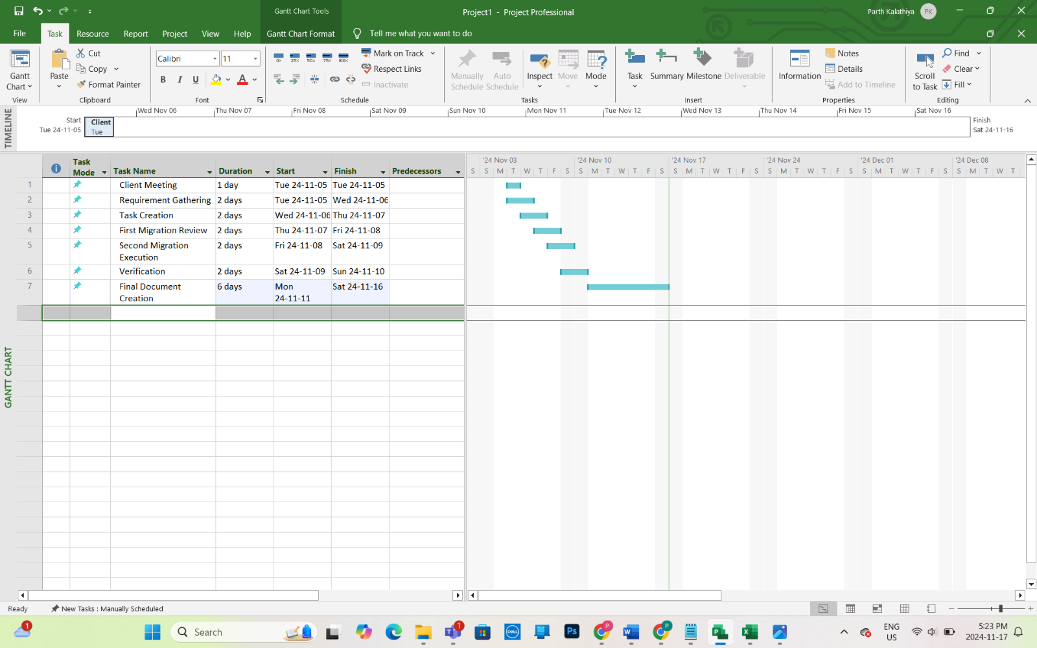

# Team Contributions

|  |  |
| --- | --- |
| Team Member | Contribution |
| Abirami Mohanasundaram | Configured document libraries and permissions. |
| Mounika Boju | Managed content migration and screenshot evidence. |
| Parth Babubhai Kalathiya | Coordinated client meetings and task updates. |
| Rechael Vincent Lopes | Finalized documentation and team communication. |

# References

NA

# Appendix

HR - Human Resources

IT - Information Technology

FAQ - Frequently Asked Questions

MS - Microsoft

FIN - Finance